RBXC 2011
Girls Cross Country

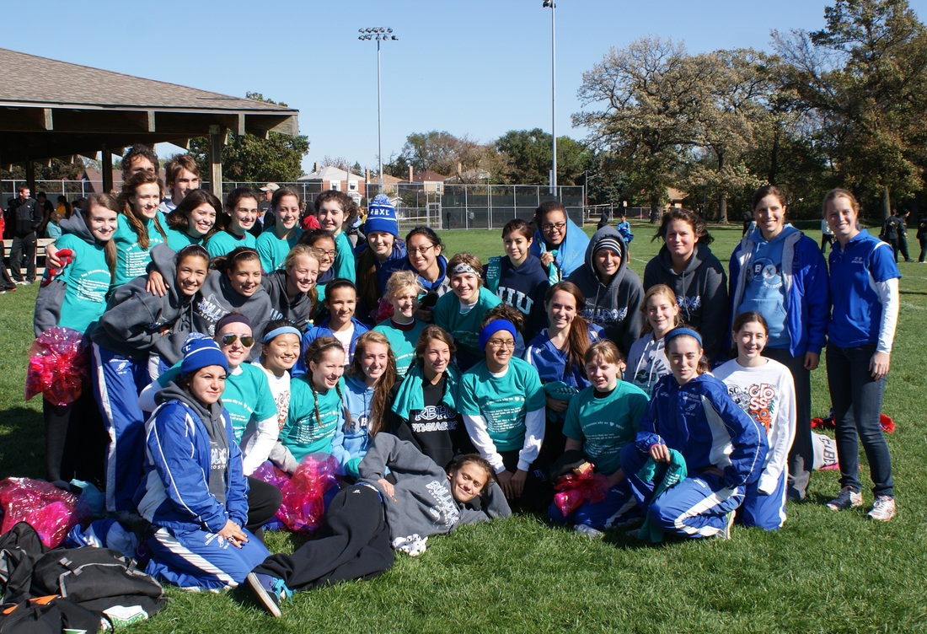

A Message from the coach…

I just want to take this opportunity to thank all the athletes and parents for making the 2011 season of Cross Country truly memorable!
To all the athletes– Thank you for your continued dedication to our program. Without you, cross country would cease to be the successful fall team sport that it is! Our team continues to grow each year, and the memories get better and better. Thank you for working hard at practice and for encouraging your teammates. This team would not feel like such a family if it weren’t for the strong team bonds that are created when many individuals work together toward a common goal. This season was the most competitive season yet, and it was more difficult than ever to get a spot on varsity. These healthy competitions lead to the fastest times that I’ve seen in several years. I’m so proud of each and every one of you. Continue to work hard, support each other, and share your love for cross country! Keep running during the off season so next year can be even better!
To all the parents – Thank you for your support throughout the season. It is so amazing to see all of you out at the races encouraging the athletes. Also, I cannot thank you enough for all your help at RB Invite and IHSA Regionals. Without the parent volunteers these meets would not nearly be as successful. Parents truly are the backbone that holds the team together, and I am so appreciative of you! Continue to spread the word to the community about how great our program is so that we can build a strong tradition and keep parent involvement growing!
Congratulations on a successful season and I can’t wait for next year!

Sincerely,

Kristi Sterling
Head Coach

Varsity Team Finishes

Sycamore Invite – 7th place
Tiger Relays – 1st place
LT Invite – 7th place
RB Invite – 2nd place
Peoria ND Invite – 40th place
OPRF Invite – 9th place
Lisle Mane Event – 5th place
Tiger Invite – 1st place
Conference – 2nd place
Regionals – 3rd place
Sectionals – 7th place

Updates from the 2011 Season…

Week #1: Aug. 29 - Sept. 3
This was a busy week for the girls cross country team! On Tuesday we traveled to DeKalb to compete in the Sycamore Invite against some of the best class 2A teams in the state. It was also our first meet and everyone did well! Varsity took 7th place with senior Maggie McLaughlin leading the way to finish 13th. JV also had great races with many girls finishing in the top 25. Wednesday we ran at Tiger Relays, which is hosted by Elmwood Park. Varsity competed in a co-ed 6 mile relay and finished 1st place as a team! Maggie McLaughlin and Travis Treviso were the champions of the night. On Saturday, we raced at the Lyons Township Invitational. Varisty finished 7th place overall (our highest finish since 2007, when I started coaching), with strong showings by the entire team: Maggie McLaughlin, Clare Bollnow, Katy Linhart, Danielle Ulloa, Kira Miller, Alma Rodriguez, and Miranda Ryan. Our freshman team looks amazing and took 3rd place overall! They were lead by Deanna Keen, Lauren Primer, and Fiona Larson. In the JV race, juniors Cynthia Gonzalez, Elaine Gaberik, and Kelly Glavin all had strong races. Next week the Bulldogs host their annual RB Invite at Sundown Meadows Forest Preserve in La Grange...come cheer them on!

Week #2: Sept. 5 - Sept. 10
The Bulldogs hosted the 52nd annual RB Invite on Friday. It was a great day and many girls stepped up to have some truly great races. Varsity battled against Nazareth Academy for the top team places. In the end, Naz won with 34 points, and RB was close behind with 36 points! Top RB finishers were: Maggie McLaughlin (2nd), Clare Bollnow (5th), Katy Linhart (7th), and Kira Miller (8th). Frosh/soph dominated yet again this week and took 1st place! Top finishers were: Caroline Waas (1st), Deanna Keen (4th), Fiona Larson (7th), and Amy Wagner (8th). We also had some amazing races in the JV race! Top finishers were: Cynthia Gonzalez (1st), Nathalie Ariza (2nd), Kelly Glavin (4th), and Elise Castelaz (7th). This season is gearing up to be one of the best in a long time! Next week the Bulldogs have a Pre-Conference meet at Elmwood Park on Tuesday, followed by the Peoria Notre Dame Invitational at the state course on Saturday...good luck ladies!

Week #3: Sept. 12 - Sept. 16
The girls made the long trek down to Peoria this week to compete in the Peoria Notre Dame Invitational on the state course. All the girls stepped up this week and almost all of them ran their best times of the season! The frosh/soph race was first, and despite being a little nervous at such a huge meet...the girls ran extremely well. They finished 23rd out of 33 teams. Fiona Larson and Deanna Keen both dropped a ton of time to finish under 21:00! Next up were the varsity girls. They rose to the challenge of running with some of the best teams in the state of Illinois. Maggie McLaughlin had the best race of her life and finished 18:52. She was closely followed by Clare Bollnow and Katy Linhart. The rest of the varsity girls (Alma Rodriguez, Caroline Waas, Danielle Ulloa, Cynthia Gonzalez, and Kira Miller) finished in a formidable pack that was only separated by 18 seconds. The varsity girls finished 40th out of 57 teams...beating many teams that have beaten us in the past. Finally, in the open race, many girls continued to run well. They were led by Elaine Gaberik and Elise Castelaz. Overall, it was a fantastic day and 10 girls finished under 21:00!!!!! Congratulations ladies! Next week the Bulldogs compete in the OPRF Invite.

Week #4: Sept. 18 - Sept. 24
This week the girls made their first appearance at the Roy Gummerson Invitational hosted by Oak Park River Forest. Despite rainy, cold weather and competition that consisted of 3A powerhouse schools, the Bulldogs held their ground! The first race was frosh/soph. Deanna Keen had a fabulous day and finished 10th place! Despite a few minor injuries, the frosh/soph girls placed 9th as a team. Next was the JV race. Kira Miller lead the Bulldogs and finished 17th. She was closely followed by Cynthia Gonzalez, and Elaine Gaberik...who both had great races as well. The JV girls had an outstanding team showing and placed 4th as a team! Finally, the varsity girls had a chance to prove they can hang with the big schools. All 7 had aggressive races and took advantage of the steep competition. Maggie McLaughlin finished 25th and was closely followed by Clare Bollnow, who really stepped up today! Behind them was Danielle Ulloa and freshman Fiona Larson. Both of these girls had incredible races and really closed the gap between our #2 and #4 runners. Overall, the varsity finished 9th out of 16 teams...a huge accomplishment when considering the field was filled with some of the top 3A schools in the state! Next week the Bulldogs run at the Lisle Mane Event at Lisle High School, come cheer us on!

Week #5: Sept. 26 - Oct. 1
The bulldogs had a fantastic weekend at the Lisle Mane Event Cross Country Invitational! The weather was perfect for running, but maybe a little windy. Frosh/soph started the day off with a 2.5 mile race. The four girls in this race (Amy Wagner, Renee Kunkel, Lauren Primer, and Jordin Duda) had aggressive races and pushed themselves to do the best they could...great job ladies! The varsity race was a long 3.1 miles, but it did not stop the Bulldogs from living up to their reputation of being tough competitors. They finished 5th place out of 21 teams (the highest finish ever at this meet!) and were led by Maggie McLaughlin who finished 15th overall despite a fall just before the 2nd mile. Katy Linhart had an awesome race and was closely follwed by Clare Bollnow (who ran extremely tough through a head cold) and Alma Rodriguez (who really stepped up today). Behind them was a fierce pack that consisted of freshmen Fiona Larson and Deanna Keen and junior Danielle Ulloa. Lastly, the girls open race was dominated by RB. Senior Kira Miller had an amazing 1st place finish, follwed by junior Cynthia Gonzalez who was 2nd, while sophomore Caroline Waas was 3rd. Juniors Elaine Gaberik and Elise Castelaz also finished in the top 10. At the awards ceremony, which is more like a pep assembly, RB won the coveted "Most Improved Spirit" award...which they worked very hard to earn! (See the pictures for a hilarious shot of Maggie with her 15th place medal) Congratulations on a great day ladies and good luck next week at Elmwood Park for the annual Tiger Invite on Thursday night.

Week #6: Oct. 3-8
This week we had the Tiger Invite at Elmwood Park on Thursday night. The heat wave proved to be a bit of a challenge since the girls were used to running in cooler weather. Varsity raced first and dominated! Maggie McLaughlin lead for 2.5 miles and was passed just at the end by a girl from Naz, but a 2nd place finish is still something to be extremely proud of! She was followed by Clare Bollnow- 6th, and Kira Miller - 9th. The JV girls tried to one-up varsity. They were led by Danielle Ulloa who finished 2nd, Caroline Waas- 3rd, Miranda Ryan, 5th, and Cynthia Gonzalez- 8th. Both teams ended up 1st place and crushed their competition! The Bulldogs also walked away with the 1st place trophy for all races combined (boys and girls). Great job! Next Saturday is Conference at Elmwood Park, and we have a shot at the title this year! Come cheer us on!

Week #7: Oct. 10-15
The Bulldogs wrapped up the regular season at the Conference meet on Saturday at Elmwood Park. Despite the heavy winds, many girls ended the season with personal record times! The varsity race was the first of the day, and although many gave it their best effort, we missed the Conference championship. They finished 2nd place behind Glenbard South. Maggie McLaughlin had a phenomenal race and walked away as the Confence Champion! She was follwed by Katy Linhart, who ran her best time of the season and finished 6th place. The two freshman on varsity (Deanna Keen and Fiona Larson) stepped up and had amazing races also! They finished 4th and 5th for our team, and 12th and 15th overall in the race. Overall we had 4 girls who were All Conference for the Varisty race: Maggie McLaughlin, Katy Linhart, Clare Bollnow, and Deanna Keen. The JV race was filled with too many great performances to mention! Danielle Ulloa was fighting hard to get back on the varsity team for the post season, and ended up the JV Conference champion with a season personal best also! Other JV All Conference girls were Cynthia Gonzalez (9th place), Caroline Waas (12th place), and Elaine Gaberik (13th place). It was a wonderful way to end the regular season! Next weekend the Bulldogs host the IHSA Regional meet at home (Sundown Meadows) and only varsity will compete. Come cheer us on!

Week #8: Oct. 17-22
The first week of the varsity post-season proved to be a successful one. We hosted IHSA Regionals at our home course (Sundown Meadows) and the varsity finished 3rd place to advance on to Sectionals next weekend. It was a close race between us and Naz, and in the end Naz got us by a mere 4 points...so look for revenge next weekend. The bulldogs were led by Maggie McLaughlin who finished 4th place and earned the title of "All Regional." She was followed by Katy Linhart, Clare Bollnow, Alma Rodriguez, Danielle Ulloa, Deanna Keen, and Fiona Larson. Everyone had a great race today and it was fantastic to see our pack back in action. Come cheer us on next weekend at Niles West High School. We run at 12:30pm.

Week #9: Oct 24-29
It was a big week for the Bulldogs as they competed in the IHSA Sectional race on Saturday. With only the top 5 teams qualifying for state and more than 20 teams in the race, we knew the competition would be tough. Varsity put up a good fight, but in the end finished 7th place as a team. Senior Maggie McLaughlin finished 12th place and landed one of the 7 individual state qualifying spots. Behind her was senior Katy Linhart, junior Danielle Ulloa, freshman Deanna Keen, junior Alma Rodriguez, freshman Fiona Larson, and finally sophomore Clare Bollnow. It was a sad end to a fantastic season for most of the runners...and we look to redemption next year. Maggie will travel to Peoria to run at Detweiller Park on Saturday morning at 11am. She will be accompanied by Katy Linhart, Danielle Ulloa, Deanna Keen, and Clare Bollnow. We are all very excited to watch our senior blow away the competition at the state meet!

Week #10: Oct 31-Nov 5

Congratulations to senior Maggie McLaughlin who finished 72nd out of 209 runners at the IHSA State meet on Saturday. She ran her personal best time of 18:49 for 3 miles. It was a great way to finish the seaon and her running career. She will be deeply missed and we wish her luck during track and at college!

Newspaper Articles…
