RBXC 2012
Girls Cross Country

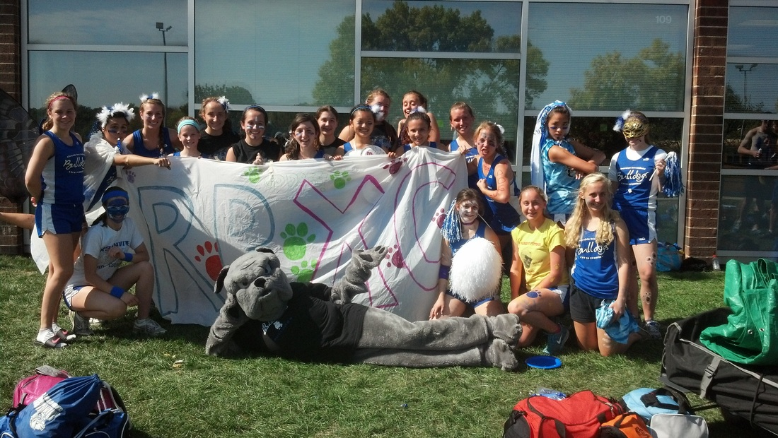

A Message from the coaches…

We just want to take this opportunity to thank all the athletes and parents for making the 2012 season of Cross Country truly memorable!
To all the athletes– Thank you for your continued dedication to our program. Without you, cross country would cease to be the successful fall team sport that it is! Our team continues to grow each year, and the memories get better and better. Thank you for working hard at practice and for encouraging your teammates. This team would not feel like such a family if it weren’t for the strong team bonds that are created when many individuals work together toward a common goal. This season was the most competitive season yet, and it was more difficult than ever to get a spot on varsity. These healthy competitions lead to the fastest times that we’ve seen in several years. We’re so proud of each and every one of you. Continue to work hard, support each other, and share your love for cross country! Keep running during the off season so next year can be even better!
To all the parents – Thank you for your support throughout the season. It is so amazing to see all of you out at the races encouraging the athletes. Also, we cannot thank you enough for all your help at RB Invite, Conference and IHSA Regionals. Without the parent volunteers these meets would not nearly be as successful. Parents truly are the backbone that holds the team together, and we am so appreciative of you! Continue to spread the word to the community about how great our program is so that we can build a strong tradition and keep parent involvement growing!
Congratulations on a successful season and we can’t wait for next year!

Sincerely,

Kristi Sterling Brennan Denny
Head Coach Assistant Coach

Varsity Team Finishes

Sycamore Invite – 7th place
Tiger Relays – 1st place
LT Invite – 9th place
RB Invite – 1st place
Peoria ND Invite – 33rd place
OPRF Invite – 8th place
Lisle Mane Event – 5th place
Tiger Invite – 2nd place
Conference – 3rd place
Regionals – 1st place
Sectionals – 8th place

Updates from the 2012 Season…

Week #1: 8/27 - 9/1
The girls cross country team began its slate of competition on Tuesday, August 28th at the Sycamore Invitational. It was a solid first run for the Bulldogs despite oppressive heat on wide open prairie terrain. Junior Clare Bollnow medaled, finishing 17th overall, and was followed by fellow RB runners Dee Dee Keen, Danielle Ulloa, Alma Rodriguez, and Sarah Melone. In the JV race, both Amy Wagner (12th) and Elise Castelaz (25th) earned awards for their performances.
The following afternoon, the girls and boys varsity cross country squads teamed up to take the championship at the Tiger Relays hosted by Elmwood Park High School. All 5 girl/boy scoring pairs cracked the top 10 overall, including girls Clare Bollnow, Dee Dee Keen, Danielle Ulloa, Alma Rodriguez, and Sarah Melone. It was an impressive showing considering that the team was on the 2nd of back-to-back meets with 90+ degree weather. In the JV open race, sophomore Lauren Primer was just the third young lady to sprint her way across the finish line!
On Saturday, September 1st, RB got their first taste of competition with larger high schools that compete in class 3A. While the Bulldogs' overall finish in 9th place will undoubtedly fuel their motivation in future meets, they had breakout performances from both veteran and novice runners. Clare Bollnow set a PR, as did sophomore Meaghan Dorsey and junior Amy Wagner. Amy continues to impress, rising to the occasion and dropping more than a minute off of her prior best time.
The RB girls next compete this Friday, September 7th at their home course (Sundown Meadows) as they host the RB Invitational. Come out and support your Bulldogs!

Week #2: 9/4 - 9/8
The girls cross country team continues to make both physical and mental improvements to their running in their second full week of competition. RB hosted the 53rd annual Riverside Brookfield Invitational at Sundown Meadows on Friday, September 7th. Despite the afternoon beginning with the humidity equivalent of a moist gym sock, the gentle rain hours before dusk provided cool and comfortable conditions throughout the majority of the races. The Bulldogs were also fueled by the fact that it had been three years since their last varsity championship on their home course, falling each of the last two seasons to their nemesis from LaGrange Park--Nazareth Academy.
In the Frosh-Soph race, both Lauren Primer (8) and Valerie Gaberik (10) finished in the top 10. The JV open race consisted of top ten finshes by Kelly Glavin (3rd), Elise Castelaz (5th), and Cynthia Gonzalez (9th). The Bulldogs continue to push through the pain, as several runners battled nagging injuries for the duration of their races. At the varsity level, the entire Bulldogs top 7 finished in the top 22 places. They were led by Clare Bollnow (2nd), Sarah Melone (6th), Dee Dee Keen (7th), and Danielle Ulloa (10th). Sarah in particular had a magnificent race--she took some calculated risks during her run, placed herself with a group of top runners, and flew up the last hill into the finishing shoot. Most importantly, RB held off Naz by 5 points for the team championship. These two rivals will undoubtedly jockey back and forth for top finishes the rest of the season, as they square off at several more big meets.
RB competes next week Tuesday, September 11th at Sundown Meadows and will journey to Peoria on Saturday, September 15th to compete with a top notch field on the course that hosts the State Championship meet in November. Continue to support your Bulldogs the rest of the way!

Week #3: 9/10 - 9/15
The Bulldogs hit the midpoint of their season this week and aimed their training towards a successful meet at Detweiler Park in Peoria, Il on Saturday, September 15th. First, however, came the pre-conference meet at Sundown Meadows, Riverside Brookfield's home course. This meet gives other conference competitors some experience on the course that will determine conference bragging rights on October 13th. Tuesday, September 11th was a sun-soaked afternoon that typified a late summer day. As a team, the varsity Bulldogs finished in 3rd place behind the tough squads of Glenbard South and Iliana Christian. RB was led as usual by junior Clare Bollnow, who crossed the finish line 9th overall.
Led by the tutelage of head coach Kristi Sterling, the RB girls have been making gains in physical performance by stressing team camaraderie and urging the girls to hold one another accountable for following through on individual/team goal-setting. As a result, the lady Bulldogs have a work hard/play hard mentality that has fostered promising team chemistry. All runners, regardless of #1 or #25, support one another both inside school and outside during training and races.
RB took a positive week into their meet on Saturday, September 15th. A brisk and dew-drop filled morning accompanied the team on their journey from Riverside to central Illinois. The day began with the Frosh-Soph race in which Fiona Larsen led the squad with a great run. Fiona is just about back to full strength after battling illness for the first part of the season. In the varsity race, several runners set PRs by dropping huge chunks of time. RB's top 5 pack of runners all finished within a minute and a half of one another, a pack that included Clare Bollnow, Dee Dee Keen, Danielle Ulloa, Alma Rodriguez, and Sarah Melone. It was a great team moment, as the runners showed how strong this team can potentially become down the home stretch of the season.
As the bus pulled away, coaches and runners alike are hopeful that this is a course that the Bulldogs will see again come early November for the state cross country meet. RB next competes this coming Saturday, September 22nd at the OPRF invite. Go Bulldogs!

Week #4: 9/17 - 9/22
On Saturday, September 22nd, the Bulldogs boarded their bus to the OPRF Invite at Schiller Woods, hosted by Oak Park and River Forest High School. The morning served as a reminder that any and all conditions are possible during cross country season. The wind sliced a path across the grassy grove, and early warmups consisted of battling the unpredictable gusts as well as sporadic driving rain. Most of the runners were equipped accordingly, sporting more layers than your favorite aunt's taco dip. As it got closer to the start of the races, the sun fortunately made an appearance and increased the average kinetic energy of the day's molecules. When several groups of Winnetka mothers arrived with their Starbucks lattes, if was officially time to toe the line...
Several PRs were set by RB this day, and a few were set during the first girls race. The frosh-soph team was led by sophomores Lauren Primer and Fiona Larsen. They were followed by Jackie LaBelle and Shannon Grehan, who returned for the first time in a few weeks due to injury. Lauren Paisker, Jemma Perry, and Ashley Lams rounded out the frosh-soph field for RB, all concluding their races with wonderful bursts up the finishing shoot.
Captain Elise Castelaz and Cynthia Gonzalez led the charge on the JV level. Elise had a great run, challenging herself against the likes of quality runners from very competitive running programs. Junior Vanessa Jebb continues to drop her best 3-mile times--like her teammates, she has been trying to push herself out of her comfort zone by holding steady with quicker runners.
The Varsity girls were paced by Clare Bollnow, who medaled with a 20th place overall finish! Sarah Melone, Dee Dee Keen, Alma Rodriguez, and Meaghan Dorsey rounded out the top 5 scoring Bulldogs during the race. Sarah proved that she deserved to be up front with Clare and the lead field as she took out the first mile extremely hard and battled the rest of the way. Meaghan showed her resolve during her run--she continues to show coaches and teammates alike her toughness as she ran her way to the team's #5 spot. While she did not have a PR, Amy Wagner displayed her classic mental fortitude, refusing to let her injury get to her head on the course.
All in all it was a successful day for the Bulldogs whose runners, depending on the timing of their finish, strode across the line to the DJ's wide-ranging musical tastes, from inner city club mixes to tracks that would be played at a wedding for a middle-aged suburban couple. The girls cross country team next competes this coming Saturday, September 29th at the Lisle Invitational. Continue to come out and support your runners!

Week #5: 9/24 - 9/29
Believe it or not, the 2012 cross country season is winding down to the stretch run; all girls on the team outside of the top 10 culminate a season filled with hard work, dedication, and perseverance at the conference championship meet on Saturday, October 13th. Our weekly Friday 6:00 am practices portray this change. The run begins dark, quiet, and peaceful, with the runners progressing from the school into their Riverside recovery run. Darkness dissipates as the Earth continues its daily rotation about its axis. The silence and soft muffled steps transform into lively conversation. The audible sounds of citizens beginning their workdays sets the backdrop for the RB cross country team striding back to the school building to continue their learning endeavors, celebrating the works of Joyce, Thoreau, and Tesla, to name a few.
On Saturday, September 29th, RB traveled to Lisle to compete in the Lions Pride "Mane Event" Invitational. The title itself inspires a jubilant giggle, as Lisle High School's mascot is the lion...hence, "Mane". Lauren Primer continued the "big cat" theme, donning her Leopard-print spikes and leading the Frosh-Soph team into the first race of the morning. Lauren, Jackie LaBelle, and Valerie Gaberik paced the Bulldogs, all finishing in the top 50 overall. In the Open race, seniors Kelly Glavin and Cynthia Gonzalez cracked the top 10 finishes, completing the 5k distance in 7th and 8th place, respectively. On the varsity level, Clare Bollnow (12th), Deanna Keen (18th), and Sarah Melone (22nd) all left with some hardware, finishing in the top 25 runners. As a team, RB finished 5th out of the 17 total teams. Notable nuggets from the race include an inspired performance by Meaghan Dorsey, who continues to push her teammates to maintain their positions on varsity, and co-captain Elise Castelaz joined the varsity squad for her second such race this season.
As the races for the day concluded, speakers at the high school inspired runners from all schools into spirited dances to the music. This meet is famous for a spirit award given to--you guessed it--the most spirited team at the meet. It's a great way for all teams to celebrate the trials and tribulations of running, support one another, and come away with positive vibes with runners from other schools at the end of a tough day of competition. While Romeoville High School took home the spirit award this day, RB led a choreographed dance to the South Korean rapper PSY (Park Jae-Sang) to the song, "Gangnam Style". The song itself is a satire on Korea's "cashed up bogans" (Herald Sun). More importantly, however, it gave all teams the opportunity to embrace their inner "sexy lady". All things considered, it was a great day to be a bulldog! Our next meet is this Thursday, October 4th at the Elmwood Park Tiger Invite. Come out and support our runners!

Week #6: 10/1 - 10/4
The girls cross country team continued their march to the end of the regular season this week by competing in the Elmwood Park Tiger Invite. This course is typically a flat, fast course that offers competitors the opportunity to set PRs, and the Bulldogs took advantage on this day. RB's Varsity squad had 4 girls finish in the top 20 overall, including Clare Bollnow (4th), Sarah Melone (10th), Dee Dee Keen (13th) and Alma Rodriguez (17th). The Bulldogs had a nice result as a team, finishing in second place. They actually tied Nazareth Academy, but the tie was broken by #6 runner Amy Wagner, who bested Naz's 6th runner by 20 places.
In the JV open girls race, 5 RB girls finished in the top 25, including champion Danielle Ulloa, Fiona Larson (7th), Cynthia Gonzalez (13th), Sam Cook (16th), Jackie LaBelle (24th) and Valerie Gaberik (25th). Fortunately, both girls races were completed prior to the lightning and thunder that interrupted one of the boys races. The Bulldogs next compete on Saturday, October 13th at Sundown Meadows as they host the Metro Suburban Conference Championship Meet.

Week #7: 10/8 - 10/13
On Saturday morning, October 13th, the girls journeyed to their home course for the 3rd out of 4 times to compete with fellow members of the Metro Suburban Conference. The day was cool and quite damp, with winds that would whip up and splash you with a fine mist. Eventually, this day would transition from mist to full-on downpour that would test the ability of the runners to handle the elements as well as their mental demons.
The first race of the day was the Varsity girls race. The RB girls proved themselves worthy competitors as they placed 4 girls in the top 20 places of a very competitive field. Clare Bollnow and Sarah Melone both set PRs on this course, whose rocky and hilly terrain challenge the footfalls of most runners. Clare (6th) and Sarah (9th) also collected all-conference individual honors by finishing in the top 13 runners. Dee Dee Keen (17th) and Meaghan Dorsey (20th) also had tremendous races. As a team, RB finished in third place behind Glenbard South and Illiana Christian, who coincidentally will also be in RB's sectional field.
The runners in the girls JV open toed the line for the final time Saturday morning. They ran inspired races--for some of the seniors, this was the final race as an RB runner. Medal winners included Elise Castelaz (9th) and Cynthia Gonzalez (10th). Lauren Primer did a marvelous job pushing through the pain on 2 sore ankles as she passed 3 runners on the final 800 meters around Lake Ida.
The Bulldogs start their postseason journey this Saturday, October 20th as they host an IHSA Regional at Sundown Meadows. Continue to support your runners!

Week #8: 10/15 - 10/20
And then there were 10. The roster for the week slimmed down to the top 10 runners to accomodate the top 7 as well as 3 alternate athletes. RB hosted an IHSA regional at their home course, Sundown Meadows, on Saturday, October 20th. The top 7 boarded the
mini-bus at 7:30am and set their sights on claiming a regional championship. Nothing gets an adolescent competitor in the mood for racing like a boy band by the name of One Direction. As the Bulldogs rolled up to the course fresh off of Pitbull's "Fuego", it was time to begin setting up camp and warming up the muscles for the first step in what hopes to be a multi-week postseason journey.
At 9:30 am, after a sassy remark from our IHSA official, the gun went off and the RB girls bolted up to the front of the pack. Coming into the race, two teams: Riverside Brookfield and Nazareth Academy were the heavy favorites to be among the top finishers. After the first 400 meters, the predictions seemed quite accurate, as all 14 of their girls were in about the top 20 places. During the last 800 meters around the lake, both teams jockeyed for position in hopes of winning the meet. As it turned out, RB held off Nazareth down the home stretch to win the regional, 30-33. The Bulldogs were led by regional champion Clare Bollnow and second place finisher Sarah Melone. Special shout-outs go to junior Amy Wagner, who hunted down 5 girls in the last half mile, and senior Alma Rodriguez, who sealed victory for the Bulldogs by literally edging out a Nazareth runner moments before crossing the finish line. Riverside Brookfield continues their postseason on Saturday, October 27th at Reed-Keppler Park in West Chicago. The top 5 teams and top 7 finishers not from qualifying teams advance to the state cross country meet in Peoria on November 3rd. Go Bulldogs!

Week #9: 10/22 - 10/27
The Bulldogs boarded their minibus at 7:30 am and headed for Reed-Keppler Park in West Chicago. As a team-inspired mix CD played on the stereo, the athlete atmosphere included quiet, focus, and perhaps pre-race butterflies. The young ladies set up camp shortly after 8:00 and began walking the course, plotting race strategies that they could employ at distinct moments during the upcoming competition. The RB girls gathered for warmups and strideouts, gathered for a pre-race chat with their head coach, and clustered in box 16 awaiting the whistle and gun from the lead official.
The race started fast, with the lead runners from Yorkville, Glenbard South, Illiana Christian, and Montini fully engaged in a fight for the top team spots. Heading into the sectional, it was clear that these four teams would comprise the top 4 in some order, leaving merely one team spot open for team qualification for the state meet next week in Peoria. RB, Lemont, Wheaton St. Francis, and Nazareth Academy were legitimate threats to finish in this coveted 5th position. The competition was extremely tough; a couple of the RB girls had standout races. Sophomore Meaghan Dorsey, junior Sarah Melone, and senior Elise Castelaz all finished with PRs, yet the Bulldogs came up a bit short as a team, finishing 8th out of the 16 total teams in the field. The Bulldogs has a great season; there were many highlights and the future is rosy--the RB girls will return 7 of the 10 girls on their postseason roster.
The team disappointment was balanced by the fact that junior Clare Bollnow qualified individually to represent herself and her school next weekend in Peoria. She finished 26th overall, and was the 6th runner out of 7 not on a qualifying team who qualified for the state competition. Clare has shown remarkable growth not only as a runner, but also and more importantly as a leader and a teammate. She has undoubtedly been the pulse of RB's team this season, cheering on her peers while approaching each practice as an opportunity to improve her performance. Her outburst of emotion immediately after realizing that she would be running at state was awesome--it was the culmination of her commitment, devotion, and perseverance. Congratulations to Clare! She will be racing Saturday morning, November 3rd at Detweiller Park in Peoria. She will be joined by Kevin Faje from the boys team, who qualified after a dramatic finish in the boys sectional race. Come out and support your Bulldogs!

Week #10: November 3rd, 2012
With sectionals a memory, Clare Bollnow headed downstate on Friday, November 1st. She was accompanied by fellow state qualifier Kevin Faje from the boys team. This was a way for Clare to cap off a wonderful junior season and set the stage for her senior campaign. The morning of state began very cool with a slight drizzle, but as the girls 2A race approached, the temperature began to warm and Clare was in positive spirits.
Throughout the race, she pushed herself and began to hunt down and overtake her fellow runners. She ended up with her best race ever, shattering her goal of breaking 19 minutes for the 3 mile race and bursting across the finish line in 18:52! It was a successful individual performance for Clare, who extended the streak for the RB girls team to either qualify individually or as a team for the 5th straight year. There is much reason for optimism next season, as the Bulldogs return 7 of their top 10 from this season's squad. It has been an honor to both coach with Kristi Sterling and work with such great kids all season!
Brennan Denny, Assistant Girls Cross Country Coach
Newspaper Articles…
9/25/2012 10:00:00 PM | Email this article • Print this article
On the run: Riverside-Brookfield runners Alma Rodriguez, left, and Meaghan Dorsey run side-by-side during the girls varsity meet at the Gummerson Cross Country Invitational Saturday at Schiller Woods.
DAVID PIERINI/Staff photographer

Riverside-Brookfield cross-country runs strong at stacked invite
Bollnow leads girls, while Faje tops out for boys team
By MARTY FARMER
Contributing Reporter
The Riverside-Brookfield cross-country teams turned in solid team performances at the Roy Gummerson Invitational hosted by Oak Park at Schiller Woods on Saturday.
Clare Bollnow led the girls team with a time of 19:51.5 on the three-mile course, good for the 21st spot. Sarah Melone checked in at 20:20.1 (34th) and Dee Dee Keen clocked a 20:25.0 (39th).
"We're having a great season so far," RB coach Kristi Sterling said about the Bulldogs, who won their 53rd annual invite earlier this month. "With only two seniors on varsity, we have a very young team but it's a talented group that's improving each weekend."
The top runner on the boys side for RB was Kevin Faje, who ran the course in 16:48. Jeremy Vasquez finished in 17:11.4 and Spencer Purcell 17:21.4 for the Bulldogs.
But it was the hosts that dominated both events. The Oak Park girls and boys finished in first and second place, respectively.
The Huskies' depth in the girls race triggered a top team finish as four runners placed among the first 12 finishers. Erin Schrobilgen ran the three-mile course in 18:31.2 to finish third overall. Katherine Powers (19:02.6/6th place), and a pair of promising freshmen in Haley Thompson (19:13.6/8th) and Ainsley Tran (19:28.5/12) rounded out the Huskies' impressive group of front pack runners.
"Erin kicked down two strong runners at the end [to take third place]," said Oak Park coach Tom Torrant. "Haley and Ainsley are coming along well, and I thought [JV runner] Rebecca Streit performed well. We are a young team that is improving and we placed on two levels [varsity, junior varsity races at Gummerson]."
Oak Park won the team title with 55 points, followed by Hoffman Estates (65), New Trier (67), Warren (137) and Fenwick (147).
Fenwick sophomore Olivia Ryan won the girls race with a time of 17:47.0, taking the course at a 5:56 per mile clip. Teammate Becky Steinmeyer also ran well for a 13th place showing when she crossed the finish line at 19:31.4.
"I think given the windy conditions and the change in weather, we performed pretty well," Fenwick coach Mickey Collins said. "Olivia ran exactly how we told her to race. We told her to find [New Trier runner] Jessica Ackerman and hang on as long as possible. It worked to Jessica's advantage as she was able to make her move with less than 400 meters to go, just holding off Jessica for the win."
Collins also credited Friars' Janeen Latz, Meghan Cahill and Ciara Hopkinson, who worked well to push each other during the race.
"The rest of our pack is still building up and developing very well," Collins added. "We should be able to work well together and move up during future races."
Prospect won the team title for the boys with 84 points, followed by Oak Park (44), Warren (99), Morton (104) and Buffalo Grove (109). Fenwick took seventh place, scoring a 218 and RB finished right behind the Friars at 230. The Friars' Pat Yerkes posted a 15:57.7, good for fifth place, while teammate Ed Egan came in 22nd with a time of 16:39.4.
Quentin Shaffer of Prospect won the boys individual title with a time of 15:11.4, followed by runner-up Martin Martinez of Warren (15:31.5) and Steven Salvano of Buffalo Grove (15:36.4).

Riverside-Brookfield Landmark
Local runners finish favorably at state meet
By MARTY FARMER
Contributing Reporter
Tuesday, November 06, 2012
RB cross country
Kevin Faje, the Bulldogs' lone boys state qualifier, recorded a time of 16:03 (pace 5:21 per mile) to finish 129th overall in the individual results of the Class 2A meet. The talented junior also led RB to a regional title and sixth place showing in sectional competition this season.
In the girls Class 2A race, RB junior Clare Bollnow recorded a personal best time of 18:52 to cross the finish line 96th. The RB girls team also claimed a regional championship this fall and took eighth place at the sectional.

TENATIVE Girls Cross Country Meet Schedule 2013
The season will begin on August 14, 2013!!
Date | Meet Name | Race Time (approx.) | Bus Time
Tuesday, Sept. 3 | Sycamore Invite @ Afton Forest Preserve, Dekalb, IL | 4:45pm | 2:30pm
Saturday, Sept. 7 | LT Invite @ LT North Campus | 8:00am | 6:15am
Saturday, Sept. 14 | First to the Finish Invitational @ Detweiller Park, Peoria | 10:20am | 5:30am!!
Tuesday, Sept. 17 | Pre-conference Meet @ Elmwood Park | 4:30pm | 3:15pm
Friday, Sept. 20 | RB Invite @ Sundown Meadows (RB Host) | 4:30pm | 2:30pm
Saturday, Sept. 28 | Oak Park River Forest Invite @ Schiller Woods, Chicago, IL | 9:00am | 6:45am
Saturday , Oct. 5 | Lisle Invite @ Lisle HS | 9:00am | 6:45am
Thursday, Oct. 10 | Tiger Invite @ Elmwood Park | 4:00pm | 2:30pm
Saturday, Oct. 12 | Sterling Invite @ Sterling, IL | 9:00am | 5:30am!!
Saturday, Oct. 19 | Conference @ Elmwood Park | 9:00am | 6:45am
Saturday, Oct. 26 | Regionals @ Sundown Meadows (RB Host) | TBA | TBA
Saturday, Nov. 2 | Sectionals @ TBA | TBA | TBA
Saturday, Nov. 9 | State @ Detweiller Park, Peoria | TBA | TBA

*Everyone will run at every meet!
*Only varsity will run at Regionals, Sectionals, and State.
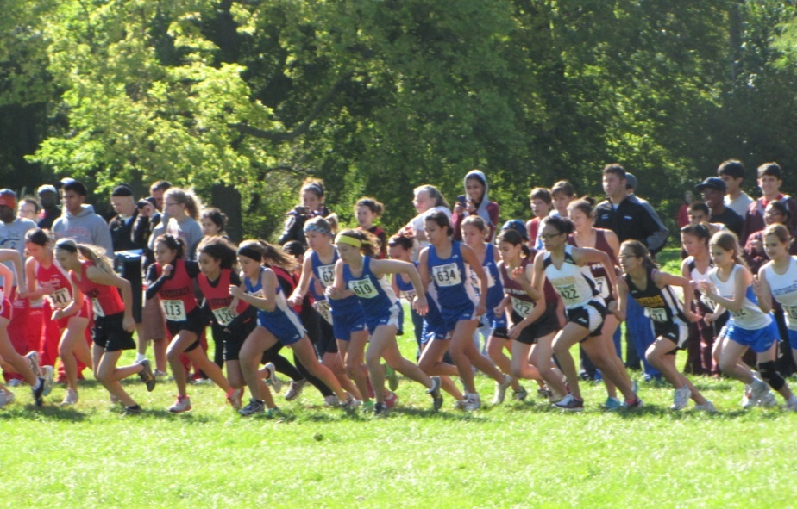
*EVERYONE will be expected to be at Regionals to help work the race/cheer on varsity since we are hosting!!

