RBXC 2013
Girls Cross Country

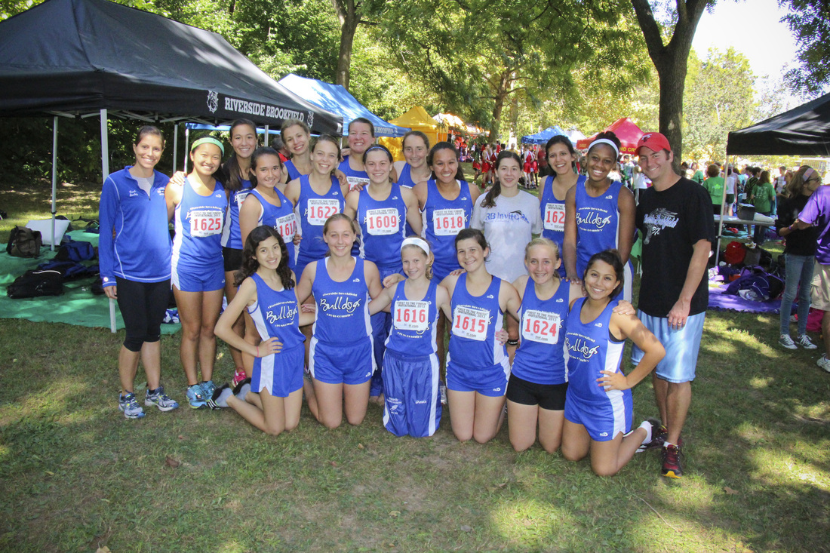

A Message from the coaches…

We just want to take this opportunity to thank all the athletes and parents for making the 2013 season of Cross Country truly memorable!
To all the athletes– Thank you for your continued dedication to our program. Without you, cross country would cease to be the successful fall team sport that it is! Our program continues to grow each year, and the memories get better and better. Thank you for working hard at practice and for encouraging your teammates. This team would not feel like such a family if it weren’t for the strong team bonds that are created when many individuals work together toward a common goal. This season was especially memorable with the addition of Mailin Struck, our exchange student from Germany. She helped our team with her hard work and commitment to the sport and led us to one of our most successful seasons yet! We also want to thank this year’s senior class…the most mentally tough group of girls we’ve ever had on cross country. To all the runners who plan on returning next year: continue to work hard, support each other, and share your love for cross country! Keep running during the off season so next year can be even better!
To all the parents – Thank you for your support throughout the season. It is so amazing to see all of you out at the races encouraging the athletes. Also, we cannot thank you enough for all your help at RB Invite and IHSA Regionals. Without the parent volunteers these meets would not nearly be as successful. Parents truly are the backbone that holds the team together, and we are so appreciative of you! Continue to spread the word to the community about how great our program is so that we can build a strong tradition and keep parent involvement growing!
Congratulations on a successful season and we can’t wait for next year!
Sincerely,

Kristi Sterling Brennan Denny
Head Coach Assistant Coach

Varsity Team Finishes

Sycamore Invite – 5th place
LT Invite – 6th place
RB Invite – 1st place
Peoria Invite – 24th place
OPRF Invite – 5th place
Lisle Mane Event – 3rd place
Tiger Invite – 2nd place
Sterling Invite – 8th place
Conference – 2nd place
Regionals – 2nd place
Sectionals – 5th place
State – 19th place

Updates from the 2013 Season…

Week #1:

Sycamore Invite
On Tuesday, September 3rd, the Bulldogs boarded their bus for a nice cruise across I-88 and a variety of back roads in farm country to race at a forest preserve in Sycamore, Illinois. This first race of the season would test the runners, as they would be competing against very tough competition in class 2A, running alongside the likes of preseason #2 University High (Normal) as well as teams to watch such as Dekalb, Belvidere North, Sycamore, and Wheaton St. Francis.
New to the Bulldogs roster this season is Mailin Struck, a 16-year-old exchange student from Germany with a background in running. She is staying with a host family in our school community and is taking the opportunity to enroll in challenging courses that will give her wonderful memories and experiences that she will take back with her to her hometown.
The varsity girls race was slightly delayed by a prior race, and the young ladies decided to fight off nerves by coming up with witty ways to “race pretty” and “finish looking beautiful” along their soon-to-be 3 mile loop. When all was ready, the gun went off, and racing season began. Mailin steadied her angst regarding her first American race with a bang, taking a commanding early lead and capturing a 1st place finish ahead of other 2012 all-state runners. Mailin was followed by Sarah Melone, Meaghan Dorsey, Clare Bollnow, and Amy Wagner to round out the top 5. The Bulldogs finished in 5th place out of 11 full varsity squads in attendance, a solid showing by a team consisting of veteran runners. (Only 6 points separated the 3rd-5th place teams!)
In the junior varsity race, RB also finished 5th as a team. The top end of junior varsity consists of a few newcomers who could ultimately challenge for spots on varsity. Junior Reilly O’Donnell, sophomore April Flores, and freshman Natalie Cote all had strong debuts and will form a strong top-10 with the seven girls currently on varsity.
Lions Pride Invitational at Lyons Township HS
This past Saturday, September 7th, RB rode the bus for a significantly shorter journey to neighbor Lyons Township to compete in the Lions Pride Invitational, a meet with several big and talented 3A schools in attendance.
This time, the junior varsity got the party started (literally, as a house in the neighborhood blasted trendy tunes to the delight of coaches and runners alike). The junior varsity squad fought off the cobwebs of an early wakeup following a long and hard week of training to display several more strong runs. Once again, the newcomers shined brightly. This time, April Flores led the charge, followed by Natalie Cote, Reilly O’Donnell, and sophomore Valerie Gaberik.
In the varsity race, Mailin Struck strode out once again to an early lead, but Glenbard South’s top runner and all-stater Diane Lipa was with Mailin for the first mile and change. During mile 2, however, Mailin began to pull away and finished an outstanding race as the 2013 champion. Senior Sarah Melone has had a wonderful start to her season, finishing in 14th place and earning a top-25 ribbon. The top 5 also had strong runs from junior Meaghan Dorsey, Amy Wagner, and Clare Bollnow. RB finished 6th place as a team and was the 2nd-best 2A finisher.
Next week, RB heads downstate to Peoria to run on the state cross country meet course against the likes of the strongest running talent in the state. If you’re in the mood to drive alongside tall grass and barnyard animals, we strongly suggest you watch what is sure to be an attention-getting race! Go Bulldogs!

Week #2:

"Bittersweet"
On Saturday, September 14th, both RB running programs met at 5:30 am to meet their bus that would take them south to the host site of the cross country championships in Peoria later in the fall. The trip itself was quiet, quick, and uneventful, despite the "Happy Birthday" serenade started by the girls team for their coaches.
Upon arrival, boys and girls alike set up camp, met with their coaches, strategized the mental and physical race challenges ahead, and readied themselves for one of the biggest races of the young season.
All girls ran together as one unit in the 2A girls race with the likes of the top-ranked teams in the state of Illinois. This would be an opportunity that would test the will of junior Mailin Struck and her teammates. After the blast of the gun, the girls took off down the long straightaway....and it was on! Mailin worked her way up to the front of the pack and settled in behind all-staters Skyler Bollinger from Yorkville and Maura Beattie from Woodstock. Skyler led all of mile 1 at a blistering pace, but Maura and Mailin pulled ahead in mile 2 with Maura leading the hundreds of runners in the race. Mailin was in close pursuit throughout, and with roughly 800 meters left, she passed Maura and surged up the gradual incline towards the finish.
Unfortunately, due to the pace of the leaders who were lapping other competitors in their 2nd mile, Mailin followed the direction of the course official directing mile 2 runners. This move sent her off course, and by the time she made it back to the finish line, she was the 3rd official finisher. Naturally, devastation set in initially, but coaches, teammates, and even fellow runners Maura Beattie and Kelsey Schrader from Dekalb, encouraged and supported Mailin's wonderful race. It's at moments like these when you find out about the quality of someone's character, and the actions and sportsmanship of these competitors proved that runners can form a very special kind of community.
While this was certainly the running showdown predicted by the prognosticators, other Bulldogs had great races. RB had PRs virtually across the board and ran tough despite lacking the services of their #2 runner, Sarah Melone. Meaghan Dorsey and Clare Bollnow worked together to pass several runners over the course of 3 miles. Amy Wagner performed great after a rough week of workouts in extreme heat, and DeeDee Keen and Lauren Primer rounded out the varsity squad. Youthful exuberance sparked performances by April Flores, Natalie Cote, and LuLu Keen in the next running pack.
While the Bulldogs didn't get that individual champion in this meet, they served notice that they can be a competitive team in a highly-regarded postseason field. Perhaps they will get another chance at this Detweiller Park course later in November....

Week #3:

"Hitting Stride"
On Tuesday, September 17th, the Bulldogs took a winding bus ride equivalent to traveling to Nebraska before reaching Bensonville, Illinois and Fenton High School. RB competed in the Pre-Conference Meet to learn the course and be able to work in key race strategies prior to the actual conference meet later in the season.
All runners competed in the same race, with some schools taking things more seriously than others. Mailin Struck coasted easily into a 1st place finish, with Sarah Melone finishing 3rd, Clare Bollnow 17th, and Meaghan Dorsey rounding out the top 20. As a team the Bulldogs finished in 2nd place, a finish they hope to at least match at the real conference meet.
Friday, September 20th, the Bulldogs hosted their annual invite at Sundown Meadows. RB would receive the toughest competition from Nazareth Academy, a team they will race against many times during the season. In the frosh-soph race, sophomore April Flores finished in second place to pace the 4 Bulldog runners: Natalie Cote, Valerie Gaberik, and Jemma Perry followed closely behind.
The varsity was led by excellent runs by Mailin Struck and Sarah Melone, who finished 1 and 2 in the field. Meaghan Dorsey, Clare Bollnow, and Amy Wagner also cracked into the top 10. The excitement came down to an uber-close team score, with RBHS winning the race with a score of 30 and Nazareth following right behind with a score of 34 points.
The Bulldogs also had strong runs (not to be confused with The Runs) in the Open Race. RB had the first 3 finishers with junior Reilly O'Donnell winning the race, senior Sam Cook hustling up the home stretch to steal 2nd away from teammate Jackie LaBelle. It was awesome to see the girls push each other to improve times against the competition.
The ladies next compete at Schiller Woods next Saturday morning in the Roy Gummerson Invitational hosted by Oak Park River Forest High School.

Week #4:

"Fisticuffs"
On Saturday, September 21st, the running lady bulldogs made their way to Schiller Woods in the city to participate in the Roy Gummerson Invitational, hosted by Oak Park and River Forest High School. A little history lesson for those as naive and ill-informed as your weekly update narrator: Roy Gummerson was born in Peoria, participated in the Olympic Games in Korea, coached at OPRF, and worked his 50th and final IHSA state track meet in 1990!
It was wonderful to see so many parents out to support our RBHS athletes on a beautifully sunny afternoon. They were joined by fans and parents of several other big high schools. Traditional powerhouses New Trier, Oak Park and River Forest, and Fenwick were accompanied by up and coming Hoffman Estates High School to lead the favorites in the girls field. Little known fact: New Trier families own the most yachts on Lake Michigan, boat shoes, and North Face puffy vests in the Chicago metropolitan area (ok so I'm improvising here but all three of these stats are highly likely given the socioeconomic level of the area).
The first race of the day for the ladies included the Frosh-Soph field. After an elaborate and colorful set of instructions by the lead IHSA official that warned runners to avoid the use of fisticuffs in jockeying for position after the start, the gun went off, and a day of competition began. The morning dew of the early morning hours gave way to quickly rising temperatures. The trio of April Flores, Natalie Cote, and Lulu Keen led the young bulldogs. April posted a PR that makes her a threat to join the varsity squad in the coming weeks of the season. Natalie used a progressive running style to edge teammate Lulu in the finishing chute--these three young ladies will be key for RB moving forward next season and beyond!
In the junior varsity Open race, Lauren Primer led the Bulldogs with the fastest time; pole vault extraordinaire Jackie LaBelle stayed with Lauren for 2+ miles and came in second for the team. Janae Dabney, Sam Cook, and Vanessa Jebb continue to slice seconds away from their previous best performances; these ladies should be quite proud of their accomplishments on a day that was difficult to avoid the heat from our heliocentric star.
As usual, the Varsity race involved some hype as junior Mailin Struck toed the line once again to test her abilities against the cream of crop in Illinois. From a team perspective, this invite usually inspires great performances from RB, as they compete against 3A schools with tons of talent and copious runners. When the gun sounded, Mailin and Sarah Melone got quick starts. The former began to distance herself immediately, while the latter tried to stay with the German gazelle as long as physically possible. Despite not having her best race and becoming fatigued in the 3rd mile, Mailin held off New Trier's Mimi Smith and Mary Blankemeier of OPRF to claim the individual title. Sarah continues to shine for the Bulldogs, once again setting a PR to finish in 15th place overall; Clare Bollnow, Meaghan Dorsey, and Amy Wagner rounded out the scoring top 5 for RB. Junior Reilly O'Donnell made her first appearance in a varsity race, finishing 7th for her team but propelling teammate DeeDee Keen forward throughout the event. The news of the day was that the bulldogs finished in 5th place, their highest team finish in the 3 years that they have run in this race.
The bulldogs next compete in the Lisle "Mane Event" Invitational next Saturday. Come out and support the team!

Week #5:

"Soggy"
After a great week of hard training, the cross country teams took their talents to Lisle (not to be confused with South Beach like the self-proclaimed King James once said) to compete in the "Mane Event" race. This race is unlike any others during the season, because the teams compete to be spirit champions in addition to waging battle with the clock.
This weekend, the Bulldogs would enter into 2 different races, the Varsity and the Open Race. This event also sheds some light on the pecking order of various teams vying for a coveted place in the upcoming state race in Peoria, as RB would face 3 other teams (Nazareth, Rosary, and Wheaton St. Francis) that will be in their sectional field.
First up was the Varsity race. The warm and humid weather, in addition to the rain that had blanketed the area the night before, left the team box in a very moist and messy state. After the gun signaled the start of the race, Mailin Struck took early control, cruising past the first mile mark with a comfortable lead. Her teammates also started strong, foreshadowing a team showdown with Nazareth that would last until all scoring runners crossed the finish line. Mailin won the race by a wide margin, setting a course record that had stood since 2003, and Sarah Melone continued her streak of medaling in the race--Sarah has taken home hardware in every meet this season with the exception of the uber-competitive "mini state" meet in Peoria earlier in September. Critical performances by Clare Bollnow and Meaghan Dorsey in the last mile helped RB surge to a 3rd place team finish, ahead of Nazareth (4th), Rosary (6th), and St. Francis (7th). This was the highest ever team finish by the Bulldogs at this race. Another noteworthy fact was the introduction of sophomore April Flores to her first varsity race--she fought early nerves in running 6th for the Bulldogs on the day.
In the girls Open race, they would run with boys from all of the participating programs. The sloppy conditions left many runners looking as though they had frolicked in the muddy Quad of a major university. As the day wore on, they also had to contend with the heat from the Sun, which showed through the mysterious cloud cover for a decent portion of the race. The ladies were led by junior Lauren Primer (19th), freshman Natalie Cote (22nd), and freshman Lulu Keen (27th).
RB races next at Elmwood Park on Thursday, October 10th. Go Bulldogs!

Week #6:

Cold Stone 'Creamery'
On Thursday, October 10th, RBHS traveled to neighbor Elmwood Park High School to compete in the Tiger Invite. While on the surface the names of the schools suggested a high level of competition, many of these same schools engage in the ultimate tease: resting their top runners in the final races leading into postseason competition. While this strategy affords teams the opportunity to give other student athletes chances to run at the varsity level, it does somewhat diminish inter-race drama.
In the Varsity girls race, senior Sarah Melone took the early lead and kept putting distance between herself and the rest of the field, cruising to an individual championship and a PR. Running mate Clare Bollnow finished 4th overall, and virtually every Bulldog crossed the finish line in personal record fashion. The JV girls were led by Sam Cook, who had a marvelous 2.25 mile race to take home the 6th place medal. As a team, the RB ladies finished 4th on the varsity level and will undoubtedly grow from a race that produced confidence-boosting times. Underrated moment of this race was the mathematics knowledge on display by the IHSA official--he actually referenced a "tangent line" in his pre-race instructions to the girls. Kudos for encouraging examples of math literacy being preached by many educators moving towards common core implementation in their classrooms!!
On Saturday, October 12th, RB boarded their First Student and headed west towards Sterling, IL to compete in the Sterling Invitational, host to 35 boys and girls programs from Illinois and Iowa. Random fact of the day--the bus driver for the girls team talked to himself more than Tom Hanks did during his time spent on the deserted island in the film Cast Away.
The team set up camp, the weather held, and the racing began. Mailin Struck hit her stride and confidently ran her way to a 50-second victory. Sarah Melone extended her streak of obtaining medals for top-tier finishes (26 overall), and the RB Varsity packed together to finish 8th out of the 35 teams in the field. They came in 2nd place after Kaneland in terms of teams in class 2A--the rest of the top finishers compete in class 3A. Senior Amy Wagner displays toughness on a weekly basis--she is an example of perseverance: nagging injuries don't prevent her from pushing her teammates to higher levels...just ask Meaghan Dorsey! April Flores and Reilly O'Donnell had solid performances as they have gotten acclimated to life at the varsity level in the past 2 weeks.
In the JV Open race, there were a couple notable outcomes. The duo of LuLu Keen and Natalie Cote continues to develop--these two freshmen ladies were the top finishers for the girls squad. Senior Vanessa Jebb participated in her last high school race, improving her best time by nearly 45 seconds. Junior Ashley Lams ran a PR by 2.5 minutes. Additionally, while cheering the boys JV teams, a few of the girls noticed that not all running shorts are created equal--whew!!
All runners will run at the Metro Suburban Conference Meet next Saturday morning. Way to go Bulldogs!

Week #7:

"Kevin FAAAAAJJJJ"
On Saturday, October 19th, the Bulldog running programs traveled to Fenton Community High School in Bensonville, IL to compete in the Metro Suburban Conference Championship Race. The Varsity squad had a productive week of training, and the JV girls tapered in preparation for the culmination of their respective seasons.
The day began with the Varsity girls race at 9:00 am. After a cleaner "wardrobe malfunction" than Janet Jackson's Super Bowl episode, the ladies were ready to compete against teams that will test them in 2 weeks at their IHSA Sectional Meet. A realistic team goal for the Bulldogs was a 2nd-place finish behind Glenbard South, currently the third-ranked 2A school in Illinois. The big question of the day would be whether RB could outrun Illiana Christian for 2nd place in the conference. When the gun sounded, Mailin Struck and Sarah Melone bolted out to the first 2 individual spots. Mailin would engage her autobahn-like cruise control for the 3 mile race and use it to coast to an individual conference championship, while Sarah would utilize a late burst on the final straightaway to steal 4th place overall. Joining Mailin and Sarah with all-conference honors would be senior Clare Bollnow (10th place). Other notes from the race: DeeDee Keen recovered from recent race struggles to turn in an inspired performance, while Meaghan Dorsey showed true grit and determination in passing 2 competitors in the finishing chute. RB accomplished its team goal, holding off Illiana Christian 53-73, and must hold off this adversary yet again in a couple of weeks if they want to run at the state meet in Peoria.
Next up for the girls this day would be the JV race. This would mark the end of blood, sweat, and tears poured into a cross country season for a number of these runners. Two freshmen led the charge for the Bulldogs, as LuLu Keen (11th) and Natalie Cote (13th) earned medals and conference recognition. Just like the Varsity team, the JV finished 2nd overall on the day, and all of the girls braved the first truly cold-temperature race of the season in accomplishing great individual finishes.
The roster gets trimmed to 10 girls beginning Monday, as RB sets sights on a 2-week mission: finish in the top 6 teams on their home course next Saturday, October 26th at the IHSA Regional, and finish in the top 5 teams in the IHSA Sectional field the following Saturday morning. Come out and support your favorite Bulldog runners at Sundown Meadows next Saturday morning.

Week #8:

"Box 8"
On Saturday, October 26th, 7 girls and 7 boys runners boarded the RBHS minibus en route to home course Sundown Meadows to begin what is hopefully a 3-race journey including regionals, sectionals, and the state race. With the radio out of commission, the runners resorted to iPods, a tremendous (?) view of Lyons, IL along 1st Avenue, and their own pre-race thoughts. On the girls side, it was going to be a two-horse race between Nazareth Academy and Riverside Brookfield.
After arriving at the course, the Varsity girls settled in, went on a leisurely warm-up, and engaged in their pre-race exercises and run-outs. With the blast of the gun, the postseason was upon them. Mailin Struck and Sarah Melone took off quickly to the front of the pack, with a smattering of RB girls and the entire Nazareth top 7 in quick pursuit. Mailin continued her streak of winning every race despite losing her prized gloves that keep her phalanges warm on a cool day. With roughly 800 meters to go, Sarah Melone was challenged by Naz's top 2 runners: Gianna Levato and Claire Ramsey. After encouragement from her coaches and embracing her "I'm not going to let myself lose this lead" mentality, Sarah widened her lead and blasted up the final hill into a 2nd place finish. Naz had the last laugh as a team, utilizing great races from their 3-5 runners to upstage the Bulldogs 27-29 as a team.
Despite the 2nd place team finish, RB maintained a positive attitude at the end of the day. This setback at regionals will make the team tougher and hungrier as they prepare for the biggest race of the season: sectionals next Saturday morning in West Chicago. This sectionals field includes some of the top 2A teams in Illinois and will undoubtedly be showcased by the individual dual between Mailin Struck and Skyler Bollinger, the sophomore standout from Yorkville that finished ahead of Mailin at Peoria earlier in the season. Come out and support your runners next weekend!

Week #9:

"Bang Splatter Splatter"
On Saturday, November 2nd, the Bulldogs boarded their team bus in focused silence. This day would mark the biggest race of the season, a culmination of the training, emotion, and dedication that these student-athletes have poured into their sport of distance running. When iPods were on and the bus radio was softly playing soulful tunes reminiscent of Detroit in 1973, it was time to make our way to West Chicago.
The race itself included class 2A powerhouses Yorkville, Glenbard South, and Montini. Throw in schools like Rosary, Lemont, Nazareth, and Wheaton Academy, and it was going to be a battle to secure a state-qualifying top-5 team finish. The Bulldogs, however, have an advantage over all of these schools, the front-running talent of Mailin Struck, who has risen to the challenge every race of the season. Today would be no different. Mailin took an early and commanding lead over the rest of the field (Yorkville super soph Skyler Bollinger battled injury during the race) and ran hard to an individual sectional championship.
RB was going to have to get a performance where all 7 girls fought hard to overcome the depth of these other quality teams. When the gun sounded, the teams jockeyed for the best line on the course. Girls sloshed their way through muddle puddles and the messiest part of the course within the first half mile. In fact, the first time the runners were visible, all had mud splashed up onto at least their legs--some had marks on their faces like war paint!
A good early sign for RB was that runners 2 and 3, Sarah Melone and Clare Bollnow, put themselves up front with the lead packs. These 2 seniors understood the urgency of the race: this could potentially be the last time they participated in a high school cross country race. These girls fought like mad and finished 17th and 27th, respectively. Clare probably had her best effort of the season, passing a competitor from Lemont just before the finish line.
Senior Amy Wagner overcame injury in turning in a valiant effort, while sophomore April Flores overcame pre-race jitters to run a very solid race and finish 6th on the team.
I'd like to highlight the efforts of the other two RB racers, Meaghan Dorsey and Dee Dee Keen. These two juniors have had very different stories all season but proved equally valuable this day. Meaghan has been a rock--she doesn't let the pressure of the moment or fear of failure deter her from being solid every Saturday. Today was no different, as she set a PR for a 5K course and held her spot strongly as the #4 runner on the team. Dee Dee Keen fully recovered from sluggish and scary finishes and had her best race of the season. Her efforts alone in the final half mile secured a state-qualifying finish for the Bulldogs, passing 4 girls including 2 in the final seconds of her run. She also finished as the #5 RB runner despite running all season as the #6 or #7.
By day's end, these collective performances put RB as the 5th place and state-qualifying team in the field, besting Nazareth by a mere 4 points (140-144). It was a treat as a coach to see the emotion of the runners and their families. RB gets the chance to fight once more next Saturday, November 9th at Detweiler Park in Peoria. If you get the chance and want to see 7 tough chicks race against the best in Illinois, it'll be worth the drive!

Week #10

"Capping a Wonderful Season"
On Friday, November 8th, the girls cross country team was escorted through the halls of RB by the band, cheerleaders, and poms on their way to their awaiting minibus that would take them south to Peoria, IL to compete in the IHSA State Finals. The next day would mark opportunities for a great team effort and, if things went according to plan, an individual state championship for Mailin Struck.
Saturday morning of the 9th was a surprisingly mild temperature for early November in the Midwest--it was a lovely day to race. Typical of the postseason was the blend of humor and focus exhibited by the girls leading up to the actual race. Coaches and parents alike got the feeling that this was going to be a special day. The team arrived at the course in time to catch the class 1A girls race and the effort of Anna Sophia Keller from Effingham (St. Anthony High School). She used her "aftergear" (sadly not my word...kudos to state final announcer Matt Piescinski for this description of her blazing finish) to take the individual title. Her time would set a standard for the day...at least for an hour and a half.
All of the prognosticators felt like the girls 2A race would be a "meatgrinder" (Matt again!) It would be a dual between Mailin and a couple of the girls that technically finished ahead of her earlier this year at Peoria. When the gun sounded, over 200 girls started chasing after the lead pickup truck carrying Matt, his color commentator, and locals wearing carharts. As the pack rounded the first turn, Mailin had worked her way to the front of the group and took control of the race. This would be as close as the rest of the field would be to her all day. She gradually widened her lead over the 3 mile race and finished 29 seconds ahead of the 2nd place girl!! This was also the fastest time in all 3 classes by fractions of a second over Anna Sophia Keller! Mailin had effectively sent a message to the rest of the runners that they would have do something that they had never done previously to upset her this day. Aside from her obvious and prolific running talent, Mailin is a wonderful teammate. Her drive to be both academically and athletically successful will propel her to do great things in her future.
The rest of the team responded with quality efforts. RB finished 19th in state out of 25 teams. Sarah Melone finished in 40th place overall, the highest ever result for a non-German RB runner. Sarah had a phenomenal season--her near-miss of state last season coupled with chasing after Mailin every workout constantly fueled her fire. Clare Bollnow had one of her fastest times of the season. While this wasn't her fastest time ever, she competed at the IHSA State Finals in 3 of her 4 years--her devotion to RB cross country has motivated many other girls to follow her tradition. Amy Wagner battled illness the last 3 weeks of the season and was rock solid on the varsity level the past 2 full seasons. She exhibits the toughness necessary to put your body through the challenging times of the cross country season. The team and coaching staff will surely miss these fine seniors!
Returning to the Bulldogs next year from the top 7 will be current juniors Meaghan Dorsey and Dee Dee Keen and sophomore April Flores. The other three girls in the top ten are very promising: freshmen Natalie Cote and Lu Lu Keen as well as junior Reilly O'Donnell. It was an honor to work with these young ladies this season. Thank you to all of the parents and families for your steadfast commitment to RBHS and the cross country program--it was definitely a season to remember!

Brennan Denny, Assistant Girls Cross Country Coach

Newspaper Articles…
German exchange student at Riverside-Brookfield a potential state cross country champion | Monday,
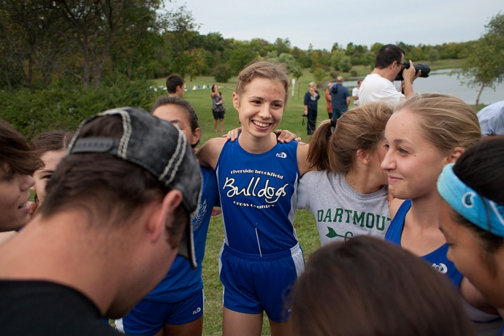
Monday, September 23rd, 2013 2:22 PM

Bob Skolnik
Contributing Reporter
About two weeks before school started this year, Riverside-Brookfield High School girls cross country coach Kristi Sterling received an email from someone she had never heard of.
Mailin Struck, a 16-year-old German girl who was going to be a foreign exchange student in the fall, emailed Sterling saying that she would like to join the cross country team.
"I had no idea what kind of talent she had at all," Sterling said. "She just said that she had been running in Germany, and she wanted to continue running over here in the United States."
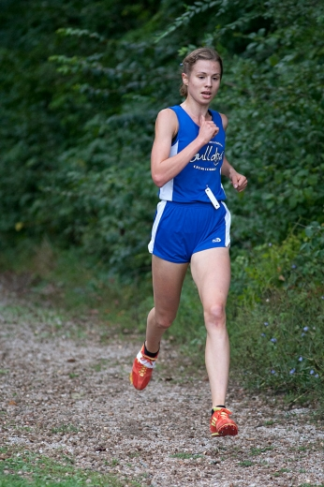
On the first day of practice when Sterling saw Struck for the first time she began to get an idea of the good fortune that had just landed in her lap.
"When she showed up on the first day, and I saw she's very tall, skinny, long legs, I figured she was going to be very fast. And when she started running for us I could tell right away that she was very fast," Sterling said.
How fast?
Well just two weeks before getting on an airplane to come to RBHS, Struck had surprised herself by finishing second in the 3,000-meter run at the Under 18 German national track and field championships, running a time of 9:41.20 on July 26.
"That was like the best day of my life," said Struck who arrived in the United States on Aug. 8
This cross country season Struck has quickly established herself as one of the best high school runners in Illinois and a potential state champion.
Struck has won four of her five races so far this season. Her closest win was by 44 seconds. But it was the race that she did not win that really showed why she is a favorite to win the Class 2A state championship in November.
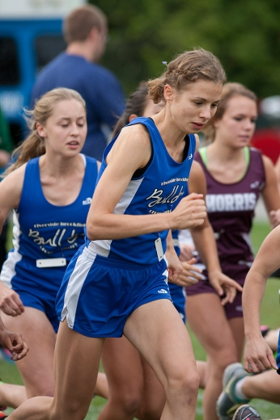
On Sept. 14 Struck ran in the First to the Finish Invitational on the state meet course at Peoria's Detweiller Park. Also in the meet was Woodstock senior Maura Beattie, the defending Class 2A state champion in the 3,200 meters, and Yorkville sophomore Skyler Bollinger, who finished fifth in the Class 2A state cross country meet as a freshman last year.
The three separated themselves from the field. Struck, who had no idea who her opponents were or what they had accomplished, trailed Beattie almost the entire race but made a move and passed her with about 500 yards to go.
But coming to the finish Struck, who was already passing runners who had one more loop of the course to go, got confused when an official appeared to be waving her to go the right for one more loop. She followed the direction instead of veering left to go to the finish chute.
She kept on going on the main part of the course as if for another loop with the slower runners until another official realized the mistake and directed her to double back towards the finish. The mistake cost her almost a minute and the race. She finished third 45 seconds behind Beattie.
"I was so angry," Struck said. "I just asked, 'Where do I have to go?' Struck said. "I was a bit angry, because I really didn't know what happened."
But she would have beaten Beattie if not for her mistake. She won't make the same mistake at the state meet on Nov. 9.
If Struck wins at the state meet she will be the second RBHS runner to win state. Jim Press won the boys championship in 1966. Katrina Price finished second in both 1986 and 1987.
Struck is from Pinneberg, Germany, a small city of about 40,000 people located about 12 miles northwest of Hamburg. She began running three or four years ago after playing field hockey.
She decided to become a foreign exchange student because she wanted to see the United States and improve her English. She just happened to be assigned to RBHS. She lives with her host mom, Debbie Ward, in North Riverside where she shares a bedroom with Wendy Zhou, an exchange student from China.
In Germany schools typically don't have athletic teams. Struck trained at a club in Germany and has had the same coach since she began running. But she enjoys the team aspect of American high school cross country.
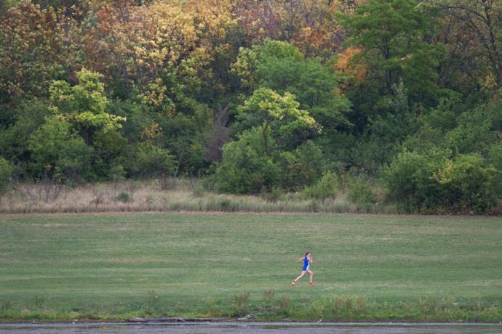
"I love the team spirit and the girls are so nice," Struck said. "It's so cool when there are other people and they cheer for you, cheer for the school. In Germany you're not feeling like you're running for the club, you run for your own glory. Here I think I'm running for my school, I'm running for my team. That's a big difference."
But that also brings pressure, particularly as word of her talent spread quickly at the school and talk turned to the possibility of a state championship.
"I feel like I always have to make the school proud," Struck said. "I feel like there's a lot of pressure on me because the school is so proud. … It sounds strange to say everyone talks about me. I think they don't know who I am, but they know there's this exchange student and she's so fast."
Having a runner as talented as Struck has posed a challenge to Sterling. Struck is more than two minutes faster than the next best runner on the team, so formulating workouts for the team and challenging Struck is not easy.
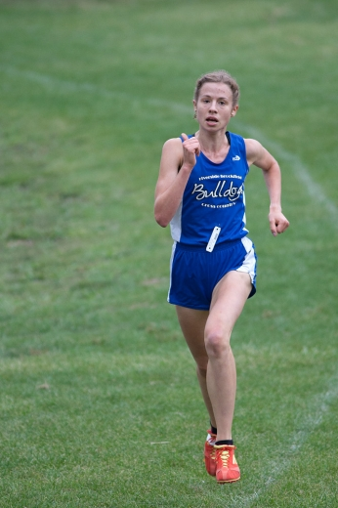
"We've been getting very creative," Sterling said. "We find ways to challenge her in practice without alienating her from the rest of the team, so we do things like we have her chase down the other girls who get a substantial head start."
They call these workouts search and destroy.
"It's really hard," Struck said. "I think it's good for me, but actually I hate it when I have to do it, but I think it's a good way of training."
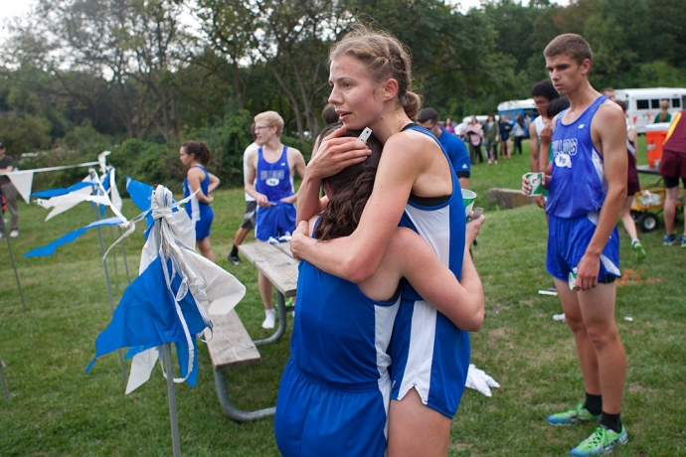
Right now Struck is planning to stay at RBHS for only one semester, because she is anxious to get back to Germany and her coach to prepare for the track season, but she could change her mind and stay the whole year at RB.
"I've thought about staying longer," Struck said. "I don't know. It's a really difficult decision."
On Saturday at the Oak Park's Roy Gummerson Invitational Struck should get a challenge from Fenwick junior Olivia Ryan, who finished fifth in the Class 3A state meet last fall.

Photos by: David Pierini
Staff photographer

Bulldogs sweep boys and girls races
Monday, September 23rd, 2013 2:22 PM
The Riverside Brookfield High School boys cross country team is off to a good start this season. The Bulldogs easily won their sixth consecutive Bulldog Invitational on their home course at the Sundown Meadows Forest Preserve in LaGrange.
The Bulldogs scored 30 points to easily outdistance second place Morris which finished with 69 points. In cross country the low score wins.
The Bulldogs placed five runners in the top nine led by senior Kevin Faje's third place finish (16:25.3). Spencer Purcell (16:33.8) finished fifth, Dan Curtin (16:37.0) was sixth, Matt Sagon (16:39.4) was seventh and Kyle Georgopolous (17:14.8) was ninth.
"The boys ran very well today," said RBHS boys cross country coach Larry Forberg. "Almost everybody on the team ran a PR, so they dropped their time, some guys as much as 50 seconds from three weeks ago when we ran here."
The RBHS girls team also won the team title by edging Nazareth. Foreign exchange student Mailin Struck led the Bulldogs with another overwhelming victory running the three mile course in 17:12.3 finishing more than two minutes ahead of the second place finisher, teammate Sarah Melone (19:21.7). A University High runner finished third followed by four Nazareth girls. But the RBHS pack of Meaghan Dorsey (8th in 20:38.4), Clare Bollnow (9th in 20:51.4) and Amy Wagner (10th in 21:00.0) secured the narrow win as RBHS finished with 30 points compared to 34 for runner up Nazareth.
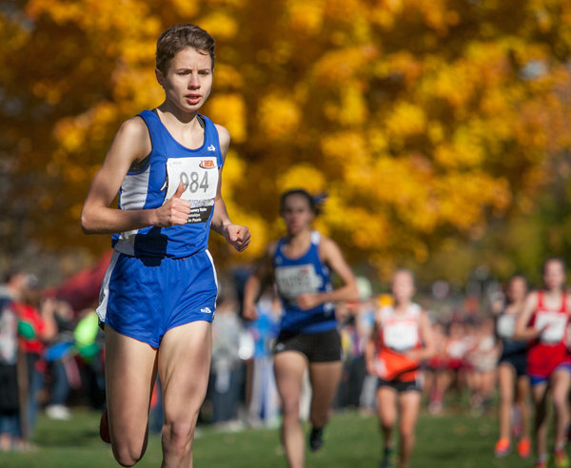
( Daryl Wilson / Chicago Tribune / November 9, 2013 )
Mailin Struck (Riverside-Brookfield) takes an early lead in the Girls Cross Country Class 2A State Finals.

Struck’s title leads Bulldogs’ charge at state
By DAN SANTAROMITA - dsantaromita@shawmedia.com
Created: Tuesday, November 12, 2013 5:00 p.m. CST
PEORIA – Mailin Struck arrived at Riverside Brookfield as a foreign exchange student from Germany this fall and gave the Bulldogs’ girls cross country team an elite runner. In return, the Bulldogs gave her the team atmosphere she desired.
Struck won the Class 2A state race on Saturday at Peoria’s Detweiller Park with a time of 16:35 that matched the fastest time across all three classes. She won the state’s biggest race by 29 seconds. The Bulldogs took 19th.
Her influence on the team helped the other Bulldog runners as well. Senior Sarah Melone placed 40th, which would have been the best finish for an RB runner in recent years.

Bulldogs' Struck wins Class 2A cross country title

RBHS runner becomes first female state champion in school history
Saturday, November 9th, 2013 6:52 PM
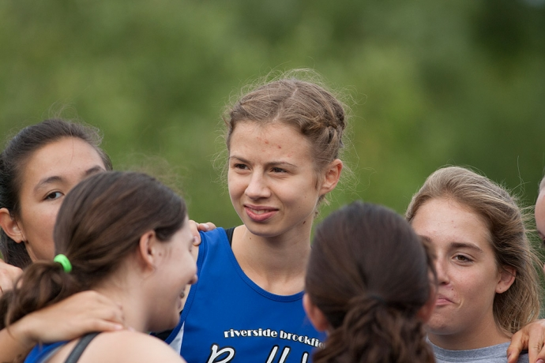
Matt Le Cren
Contributing Reporter
Mailin Struck has only been in the United States for three months, but in that short time she has burst onto the local sports scene like a meteorite blazing through the sky.
Struck, a foreign exchange student from Germany, will disappear just as quickly but what she has accomplished will never be forgotten at Riverside-Brookfield High School.
Struck won the Class 2A cross-country championship in dominating fashion Saturday at Detweiller Park in Peoria to become the first female state champion in any sport at RBHS. Her time of 16:35 was 29 seconds better than runner-up Maryjeanne Gilbert of Peoria Notre Dame and the eighth-fastest in Illinois history.
"It was very exciting," RBHS coach Kristi Sterling said. "We anticipated that she was going to go out and be very competitive but she blew away all of our expectations and shifted into another gear that we hadn't known she had. It was very cool to see her win."
Sterling had no idea her program would produce a state champion before Struck arrived in town on Aug. 8. Struck, who will turn 17 on Nov. 21, is one of the top young runners in Germany. She finished second in the 3,000-meter run at the Under-18 German national championships in July, but Sterling didn't know that.
"Mailin just got randomly placed here,"Sterling said. "She could have gone anywhere."
Instead, she came to RBHS and went places no Bulldog has gone before. Struck will return in January to Germany, where she has two more years of high school left, but her visage will remain permanently at RBHS, which was her main motivation Saturday.
"The week before I told my coach the only reason I wanted to win this is to have my picture on the wall," Struck said. "She was like, 'What, that's the only reason?' It was pretty funny."
Struck has enjoyed her time in America but she feels pressure just like any serious athlete. Those pressures were eased by the camaraderie she established with her fellow runners
"I really love my team and I couldn't have made it on my own," Struck said. "It is tough to train on my own. Maybe some people can accomplish stuff like that, but I can't.
"I'm so glad I have teammates because before the race I'm really anxious and I'm in a bad mood, but they're supporting me. It's nice to know they are behind me and the coaches worked hard to get me ready. They did a fantastic job."
Struck was aware of the buzz her performances have generated at school but didn't realize she had become a trailblazer until after her victory.
"The week before all the teachers were talking about it in class, telling everyone I had a chance to win," Struck said. "I am hearing this all the time, [that] some people expect me to win and it was kind of a goal for me. There was the possibility that I can win so it was kind of stuck in my head. It worked out pretty well."
With Struck in the lineup, the Bulldogs advanced to the state meet for the third time since 2008. Most German schools do not offer interscholastic sports, so this season was a new experience for Struck, who has trained with a club coach for the past four years,
"They don't really have school sports inGermany, so to run with other people and teammates is kind of a rarity for her,"Sterling said. "This was kind of once-in-a-lifetime opportunity for her."
It was also a unique opportunity for RBHS, which has produced just eight previous state champions, all boys, in over a century of competition. Only one of those was a cross-country runner: Jim Press, who won the 1966 title. The school had only one previous state medalist, four-time medalist Katrina Price, who was second in 1986 and 1987.
Struck's championship helped the Bulldogs finish 19th in the 25-team field with 391 points. Senior Sarah Melone finished 40th in 18:36, while senior Clare Bollnow (106th, 19:34), junior Meaghan Dorsey (163rd, 20:30) and junior Deanna Keen (190th, 21:15) were the other scorers. Senior Amy Wagner (192nd, 21:31) and sophomore April Flores (210th, 23:06) also competed.
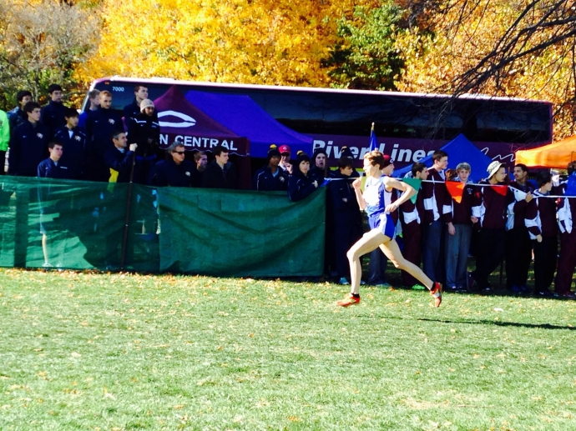
Of that group, only Bollnow, a three-time state qualifier, had previous state finals experience. They all have Struck to thank for the opportunity.
"Having her around has really boosted everything in relation to my team,"Sterling said. "Just seeing an athlete of that caliber, seeing what she eats, how she takes care of her body and seeing her work ethic, is new to the girls."
"She's all-around just a great person. She's been nothing but wonderful for our team." Struck already has been invited to join the German national track team and could represent Germany at the 2014 Under-20 World Championships next summer in Eugene, Oregon. She laughs when her fellow students talk about one day watching her compete in the Olympics, but said she will always remember her state title.
"I'm really proud," Struck said. "I think the school is proud of me even though I'm still new. I feel like a real student."

TENATIVE Girls Cross Country Meet Schedule 2014

The season will begin on August 13, 2014!!

Date | Meet Name | Race Time (approx.) | Bus Time
Tuesday, Sept. 2 | Sycamore Invite @ Afton Forest Preserve, Dekalb, IL | 4:45pm | 2:30pm
Saturday, Sept. 6 | LT Invite @ LT North Campus | 8:00am | 6:15am
Saturday, Sept. 13 | First to the Finish Invitational @ Detweiller Park, Peoria | 10:20am | 5:30am!!
Tuesday, Sept. 16 | Pre-conference Meet @ Elmwood Park | 4:30pm | 3:15pm
Friday, Sept. 19 | RB Invite @ Sundown Meadows  (RB Host) | 4:30pm | 2:30pm
Saturday, Sept. 27 | Oak Park River Forest Invite @ Schiller Woods, Chicago, IL | 9:00am | 6:45am
Saturday , Oct. 4 | Lisle Invite @ Lisle HS | 9:00am | 6:45am
Thursday, Oct. 9 | Tiger Invite @ Elmwood Park | 4:00pm | 2:30pm
Saturday, Oct. 11 | Sterling Invite @ Sterling, IL | 9:00am | 5:30am!!
Saturday, Oct. 18 | Conference @ Elmwood Park | 9:30am | 7:00am
Saturday, Oct. 25 | Regionals @ Sundown Meadows  (RB Host) | TBA | TBA
Saturday, Nov. 1 | Sectionals @ Kress Creek Farms, West Chicago (Wheaton Academy Host) | TBA | TBA
Saturday, Nov. 8 | State @ Detweiller Park, Peoria | TBA | TBA

