RBXC 2010
Girls Cross Country

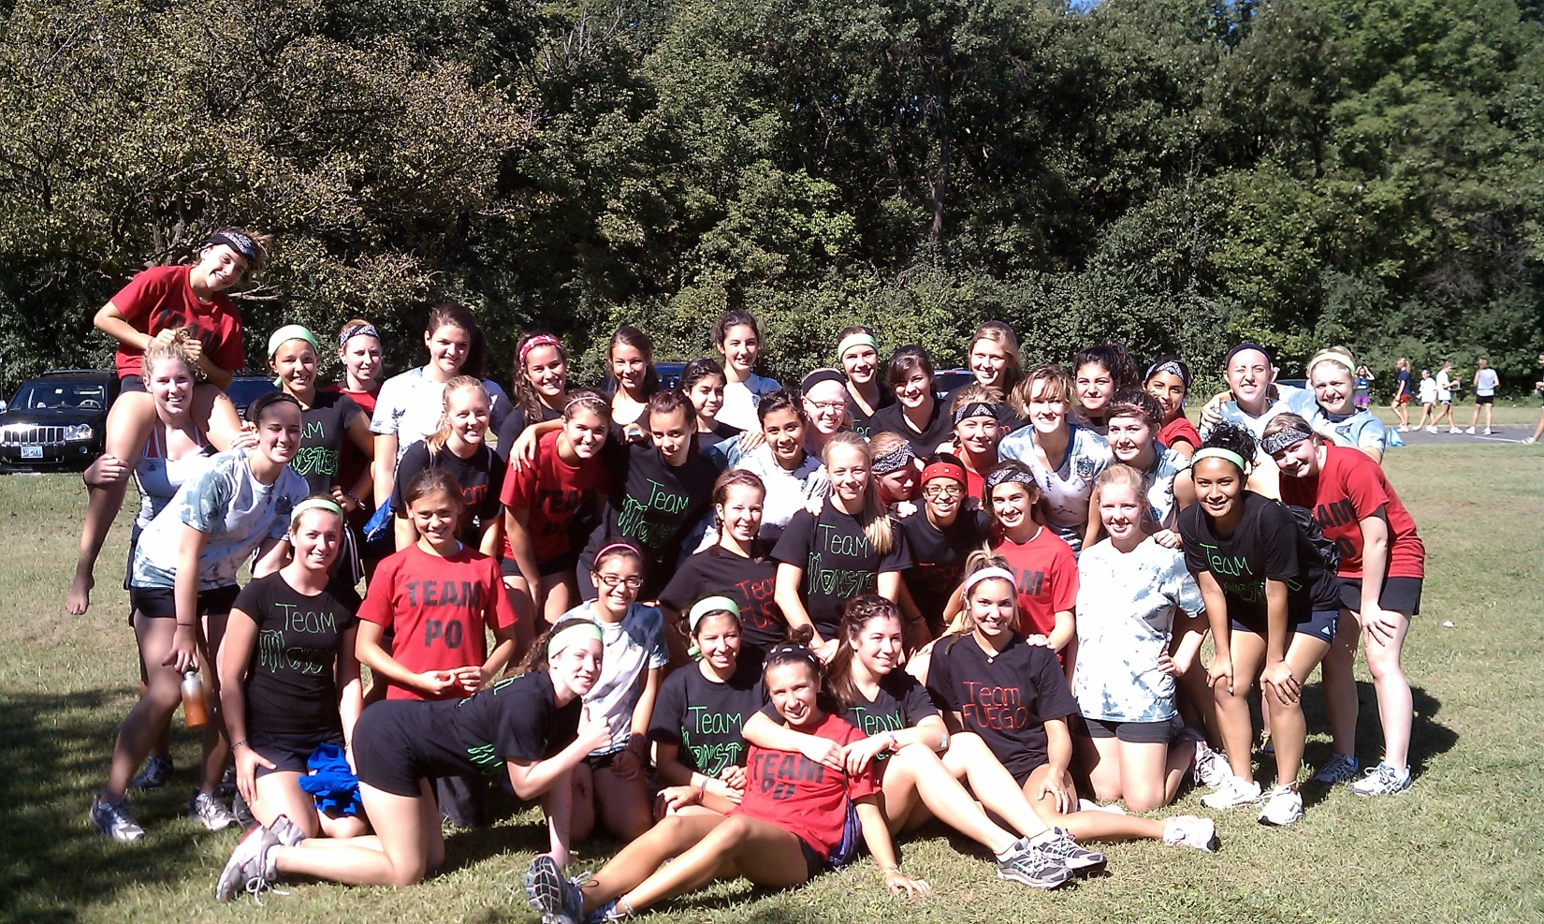

A Message from the coaches…

We just want to take this opportunity to thank all the athletes and parents for making the 2010 season of Cross Country an unbelievable one!
To all the athletes– Thank you for your continued dedication to our program. Without you, cross country would cease to be the successful fall team sport that it is! Our team continues to grow each year, and the memories get better and better. Thank you for working hard at practice and for encouraging your teammates. This team would not feel like such a family if it weren’t for the strong team bonds that are created when many individuals work together toward a common goal. This season was the most competitive season yet, and it was more difficult than ever to get a spot on varsity. These healthy competitions lead to the fastest times that we’ve seen in several years. We’re so proud of each and every one of you. Continue to work hard, support each other, and share your love for cross country! Keep running during the off season so next year can be even better!
To all the parents – Thank you for your support throughout the season. It is so amazing to see all of you out at the races encouraging the athletes. Also, we cannot thank you enough for all your help at RB Invite and Regionals. Without the parent volunteers these meets would not nearly be as successful. Parents truly are the backbone that holds the team together, and we are so appreciative of you! Continue to spread the word to the community about how great our program is so that we can build a strong tradition and keep parent involvement growing!
Congratulations on a successful season and we can’t wait for next year!

Sincerely,

Kristi Sterling Brennan Denny
Head Coach Assistant Coach

Updates from the 2010 Season…
Week in Review: September 4-11, 2010
Varsity & Frosh/Soph
The RB girls hosted their annual RB Invite on Friday, September 10th. The Frosh-Soph team won the invite and had four scoring finishers in the top 10 and 5 scoring finishers in the top 25. The Frosh-Soph bulldogs were led by Alma Rodriguez (1), Kelly Glavin (3), Caroline Waas (5), Danielle Ulloa (6), Elise Castelaz (10), and Emily Filec (18). The varsity girls finished 2nd overall, had 6 girls finish in the top 25, and were paced by Maggie McLaughlin (3), freshman Clare Bollnow (6), Gabby Ulloa (13), Miranda Ryan (17), Rachel Rodriguez (20), Kira Miller (22), and Katie Linhardt (26). Congratulations to all athletes! The Bulldogs next compete in their Pre-Conference Meet on Tuesday, September 14th at Fenton High School.
Week in Review: September 12-18, 2010
Varsity & Frosh/Soph
The girls' cross country team finished 3rd on Tuesday, September 14th at the Metro Suburban Pre-Conference Meet at Fenton High School. On Saturday, September 18th, the Bulldogs competed in the Richard Spring Invitational at Detweiller Park in Peoria, Illinois. Many of the girls set personal record times against high quality competition from around the state. The top 5 finishers on the varsity level were Maggie McLaughlin (jr), Gabby Ulloa (sr), Clare Bollnow (fr), Alma Rodriguez (so), and Rachel Rodriguez (sr). The top 5 frosh-soph girls were Sarah Melone (fr), Danielle Ulloa (so), Caroline Waas (fr), Elise Castelaz (so), and Rachel Decosola (so). The team will run next weekend at the Whitney Young Invitational in Chicago. Go Bulldogs!!
Week in Review: September 19-25, 2010
Varsity & Frosh/Soph
The Girls' Cross Country team had a very successful week, culminating at the Whitney Young Invite in Chicago on Saturday, September 25th. The Frosh-Soph team finished 4th overall and had four girls finish in the top 25: Miranda Ryan (6th), Sarah Melone (15th), Caroline Waas (20th), and Danielle Ulloa (22nd). The Varsity squad finished 2nd as a team and were also led by four top 25 finishers: Maggie McLaughlin (12th), Jacki Grisafe (15th), Gabby Ulloa (19th), and Clare Bollnow (20th). The Bulldogs' can hang their success on the cohesiveness and competitiveness of their lineup; their 5 scoring varsity runners, including Alma Rodriguez, were separated by only 50 seconds. Go Bulldogs!! RB will compete next at an invitational at Lisle High School on Saturday, October 2nd.
Week in Review: September 26- October 2, 2010
Varsity & Frosh/Soph
The frosh-soph girls cross country team finished 6th out of 21 teams at the Lisle Invitational on Saturday, October 2nd, while the Varsity girls finished 7th. The frosh-soph team was led by the freshman tandem of Caroline Waas and Sarah Melone, who finished their 2.5 mile races in 18:28 and 18:29, respectively. Maggie McLaughlin led the Varsity Bulldog pack during the 5K (3.1 mile) race with a time of 21:24. All five scoring scoring runners (McLaughlin, Clare Bollnow, Jacki Grisafe, Gabby Ulloa, and Alma Rodriguez) finished within 53 seconds of one another. The Bulldogs finished just behind conference rival Ileana Christian (6th) and just ahead of Nazareth Academy (8th). Come cheer on both levels of the cross country team this Thursday, October 7th at Elmwood Park High School!
Week in Review: October 3-9, 2010
Varsity & Frosh/Soph
The junior varsity and varsity Bulldogs had successful outings at the Elmwood Park Invitational on Thursday, October 7th. Both levels finished 1st as a team. Many of the varsity girls set personal record (PR) times during the meet and utilized a tight-knit pack to lead them to victory. Maggie McLaughlin, Jacki Grisafe, Gabby Ulloa, Alma Rodriguez, and Miranda Ryan led the varsity squad. The junior varsity girls dominated their race, led by Katy Linhardt, Sarah Melone, Rachel Powell, Rachel Rodriguez, and Caroline Waas. Come cheer on the cross country program next Saturday, October 16th at Fenton High School for the Metro Suburban Conference Meet.
Week in Review: October 10-16, 2010
Varsity & Frosh/Soph
The Varsity girls' cross country team finished 2nd in the Metro Suburban Conference Meet on Saturday, October 16th. Glenbard South won the championship with 27 points, RB had 63 points, and 3rd place finisher Illiana Christian had 69 points. The Bulldogs were led by their top 5 of Maggie McLaughlin, Jacki Grisafe, Gabby Ulloa, Clare Bollnow, and Alma Rodriguez. The junior varsity team won the conference meet, finishing ahead of Glenbard South (2nd) and Illiana Christian (3rd). The top 3 individuals in the field were all Bulldogs: Rachel Powell, Katy Linhart, and Sarah Melone. Caroline Waas (6th), Rachel Rodriguez (8th), and Kira Miller (10th) all finished in the top 10. RB hosts their regional meet next Saturday, October 23rd at Sundown Meadows. Come out to cheer on the Bulldogs!

Week in Review: October 17-23, 2010
Varsity
The Varsity girls' cross country team had a productive weekend, earning a 2nd place finish in the Riverside Brookfield Regional. The Bulldogs finished 5 points behind rival Nazareth Academy, and held off 3rd place finisher Lemont by 1 point. All three teams advanced to the Sectional meet next weekend at Niles West High School. RB was led by Maggie McLaughlin (5th overall), Clare Bollnow (6th), Jacki Grisafe (8th), Miranda Ryan (11th), and Gabby Ulloa (12th). Come up to Niles West next Saturday to cheer on the Bulldogs as they compete for a spot at the state meet on November 6th at Detweiller Park in Peoria!
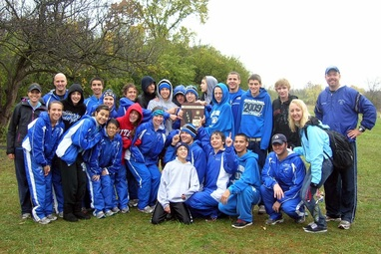
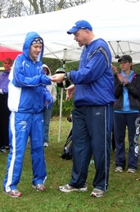

Bulldog Cross Country teams at the IHSA Regional Meet

Maggie McLaughlin receiving her 5th place medal at the IHSA Regional Meet
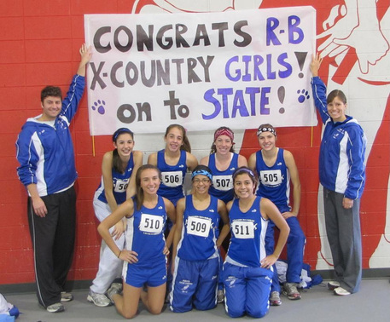
Week in Review: October 24-30, 2010
Varsity
The girls' cross country team qualified for the state meet in Peoria for the 2nd time in the last 3 years after finishing 4th in the Nazareth Academy Sectional on Saturday, October 30th at Niles West High School. The Bulldogs were led by great performances from freshman Clare Bollnow and sophomore Miranda Ryan, who both stepped up to fend off key competitors from the other schools. Scoring team members included Clare Bollnow, Maggie McLaughlin, Miranda Ryan, Gabby Ulloa, and Jacki Grisafe. The top 5 teams advancing to the state meet from this sectional are:
1. Nazareth Academy
2. Hillcrest
3. Illiana Christian
4. Riverside Brookfield
5. Lemont
The RB cross country program would love to see students, parents, teachers, administrators, and the community down in Peoria! Congratulations, Bulldogs!

Week in Review: November 1-6, 2010
Varsity
The girls' cross country team wrapped up their season Saturday, November 6th at the IHSA State Meet in Peoria, IL. The Bulldogs finished 20th in Class 2A, and the majority of the top 7 concluded their seasons with PR times! The state team consisted of seniors Jacki Grisafe, Gabby Ulloa, Rachel Powell, and Rachel Rodriguez; juniors Maggie McLaughlin, Katy Linhart, and Kira Miller; sophomores Miranda Ryan, Alma Rodriguez, and Kelly Glavin; and freshman Clare Bollnow. Coach Sterling and Coach Denny are extremely proud of the cross country team and want to thank all of the parents, families, and friends who cheered on the Bulldogs during their wonderful season.

Newspaper Articles…
Bulldogs Ready for Cross Country Season
By Ryan Long, rlong@mysuburbanlife.com
Posted Sept 16, 2010
Riverside, IL — AT A GLANCE
Nickname Bulldogs
Conference Metro Suburban Conference
Home course Sundown Meadow Forest Preserve
2009 results 6th at sectionals
Coach Kristi Sterling
Top returnees
Maggie McLaughlin jr.
Jacki Grisafe sr.
Gabby Ulloa so.
Rachel Powell sr.
Rachel Rodriguez sr.
Promising newcomer
Clare Bollnow fr.
OUTLOOK
After finishing sixth at sectionals in the 2009 season, coach Kristi Sterling hopes to improve off that finish in 2010. The Bulldogs lost many of their top runners from last year, including Samantha Oberholtzer who qualified for state individually, and Sydney Oberholtzer. Riverside Brookfield also lost Anna Tess but their other four runners return from a team that won its region title a year ago.
“We’ve had a lot of people trying to get on varsity so everyone’s improved,” Sterling said. “It’s a lot harder to get on varsity than in year’s past.”
Sterling credited her seniors with helping give the team the right direction on the path to state.
“We have four team captains this year that lead us through all of our stretching,” Sterling said. “They serve as role models for the rest of the team. We have a big team and it makes my job a lot easier.”
One other run to watch is freshman Bollnow who has impressed Sterling in her first season with the team.
Staff writer Ryan Long can be reached at rlong@mysuburbanlife.com or (630) 368-8954.
Copyright 2010 Brookfield Suburban Life. Some rights reserved
Bulldogs Blaze Trail Back to State
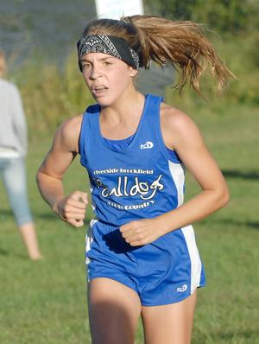
By Ryan Long, rlong@mysuburbanlife.com
Brookfield Suburban Life
Posted Nov 03, 2010
Brookfield, IL —
Last year, Riverside Brookfield’s girls cross country team just missed out on a trip to state with a sixth-place finish at the Class 2A Nazareth sectional.
Last Saturday, the Bulldogs made a big step forward, finishing fourth at Nazareth’s sectional for a ticket to Detweiller Park in Peoria this weekend.
Freshman Clare Bollnow led the way with her 15th-place time of 20:21.72.
Joining Bollnow will be teammates Maggie McLaughlin (24th in 20:47.02), Miranda Ryan (32nd in 20:56.07), Gabby Ulloa (33rd in 21:00.03), Jacki Grisafe (34th in 21:01.83), Alma Rodriguez (64th in 21:52.41) and Rachel Powell (72nd in 22:11.98).
Clare Bollnow approaches the finish line for Riverside-Brookfield High School in the girls varsity run in a multi-school cross country meet at Sundown Meadow in Countryside on Friday, Sept. 10, 2010. Clare is RB's second runner to finish the race. snapshots.mysuburbanlife.com/1073448
Bill Ackerman
Even if the team had not advanced, Bollnow still would have qualified for state as an individual. In 2009, the recent RB graduate Samantha Oberholtzer competed by herself and came in 51st place (19:26) at the state meet. Bollnow will have the distinct advantage of having her teammates on the course to push her.
Running to an end
Behind Keegan Buttimer’s 23rd-place finish at the Class 2A Nazareth sectional, Riverside Brookfield boys cross country closed out the 2010 campaign with a sixth-place finish.
The Bulldogs just missed qualifying for the state meet for the second straight season — this year by a mere four points. RB was edged by Kenwood 143 to 147 for the final qualifying spot.
Also competing for RB on Saturday were Chris Schomer (29th, 17:23.29), Joey Melone (30th, 17:23.31), John Keen (32nd, 17:26.57), Kevin Pardo (38th, 17:39.13), Travis Trevizo (43rd, 17:48.90) and Dan Curtin (54th, 17:58.54).
Staff writer Ryan Long can be reached at rlong@mysuburbanlife.com or (630) 368-8954.
Copyright 2010 Brookfield Suburban Life. Some rights reserved

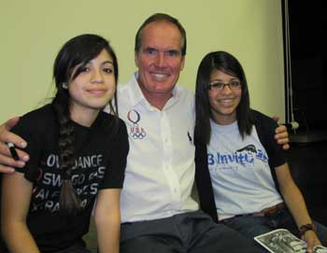
RB runners get a visit from the best
Olympic runner Craig Virgin stops by to motivate cross-country team
By BOB SKOLNIK
Contributing Reporter - Landmark
The best cross country runner ever from the state of Illinois came to Riverside-Brookfield High School Friday evening to speak to the RB boys and girls cross country teams.
Craig Virgin delivered an inspirational and motivational message to the RB runners. He exhorted them to restore RB to its glory days in cross county in the late 1960's and early 70's when RB was a state power, culminating in a second place team finish at the 1973 state cross country meet.
A year before, Virgin, who is from downstate Lebanon High School, set the state meet course record of 13:50.6 on the 3-mile course at Detweiller Park in Peoria, a record that still stands today some 38 years later. In that 1972 race, Virgin won his second of his two state individual titles in cross country.
Running man: Former U.S. Olympic runner Craig Virgin poses with Danielle Ulloa (left) and Gabby Ulloa during a recent visit to Riverside-Brookfield High School.
That was only the start of a brilliant running career. In 1973, Virgin set a national high school record running in the 2-mile run with a time of 8:40.9. He went on to run for the University of Illinois and eventually made three U.S. Olympic teams (1976, 1980, and 1984) in the 10,000-meter run and is the only American man to win the world cross-country championship (1980 and 1981).
Friday night, wearing a U.S. Olympic team white shirt, Virgin thrilled the assembled runners and many of their parents with video clips of his high school state championship races and his come-from-behind win in the 1980 World Championship cross-country race.
Virgin told the RB runners that hard work, self confidence and mental toughness were keys to his success.
"The biggest secret to success is hard work," Virgin said. "This is not a cheap sport. You've got to make a commitment. Mental toughness is believing in yourself. Mental toughness is a combination of attitude and experience."
Riverside-Brookfield freshman Clare Bollnow, who asked Virgin how he stayed so mentally tough in races, found his answer inspiring.
"I thought he was really motivational and I thought it was great to hear him talk right before the postseason," Bollnow said. "I think it's getting everyone in a good mental attitude right at the time you need it."
Dan Curtin, a freshman who ran his first varsity race last week, said that he was motivated by Virgin.
"It was just like really inspiring," Curtin said. "Before I was like mostly serious about cross country and I was like yeah I kind of want to run in the winter, but now I actually think I'm going to push myself to commit (the) whole year round."
Virgin came to RB because he was in Chicago for Sunday's Chicago Marathon and because he has some connections to the school. He went to high school with Jeanine Buttimer, the mother of the boys team's top runner, Keegan Buttimer. Jeanine was a cheerleader at Lebanon High School, cheering Virgin on when he set his high school records.
But that was not Virgin's only connection to RB. Pat Mandera, who finished seventh at the 1969 State Cross-country Meet when he was a senior at Morton East and raced against Virgin in college, is the father of RB senior cross country runner Ryan Madera.
Last week in their last tune-up before the conference meet, both the girls and boys teams finished strong at the Elmwood Park Tiger Invitational.
The girls won the varsity title with 56 points. Leading the way for the Bulldogs was Maggie McLaughlin who finished fifth in a time of 19:36. Jacki Grisafe was close behind finishing seventh in 19:43 and Gabby Ulloa (20:11), Miranda Ryan (20:12) and Alma Rodriguez finished close together in 13th, 14th and 17th.
The RB boys varsity team finished third behind Joey Melone's 16:58 finish.

Foundation set at state
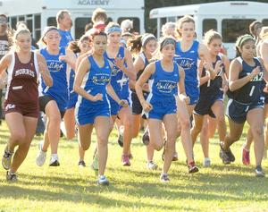
By Ryan Long, rlong@mysuburbanlife.com
Posted Nov 10, 2010
Brookfield, IL —
First-year Riverside Brookfield girls cross country coach Kristi Sterling admits to being in the early stages of building the program.
But the Bulldogs laid a great foundation Saturday by competing as a team at the Class 2A state meet at Detweiller Park in Peoria. And on the biggest stage, a majority of the pack collected personal best times.
“It was a very fast race this year,” Sterling said. “Our goal was to get downstate and our young team wants to get to the point of expecting to qualify for the state meet every year. We don’t just want to get down there anymore, we want to place well too. We now have some more experience and self-confidence. We need to continue to put in the effort.”
Riverside-Brookfield High School athletes start the varsity girls run in a multi-school cross country meet at Sundown Meadow in Countryside on Friday, Sept. 10, 2010.
Bill Ackerman
Junior Maggie McLaughlin turned in the Bulldogs’ top time of 19:43 to place 92nd. Sophomore Gabby Ulloa was 94th (19:47), senior Jacki Grisafe came in 96th (19:51), freshman Clare Bollnow was 109th (20:05), sophomore Alma Rodriguez came in 116th (20:11), sophomore Miranda Ryan was 117th (20:11) and senior Rachel Powell came in 131st (20:50).
“I couldn’t ask for a better first year as a head coach,” Sterling said. “Our times kept getting faster throughout the season and I’m excited to see the program grow. We’re going to have some spots to fill because of graduation, so we’ll see how we develop during the offseason.”

