Sundown Meadows:
Riverside Brookfield Cross Country Home Course
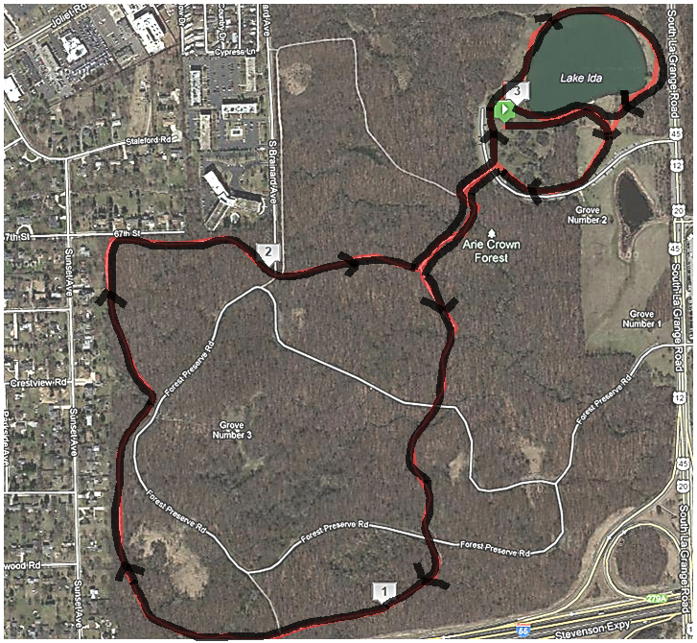

More details on the next page

Close up of the starting line and lake:
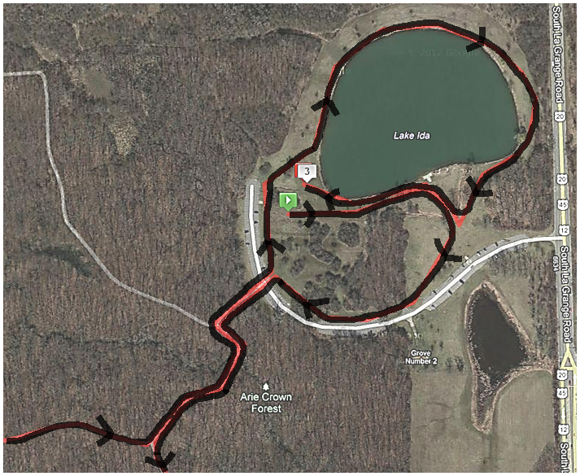

From the starting line:
Keep right to take the loop away from the lake.

In the Forest:
All left turns except one right turn at the very end to exit the forest.

After the Forest:
Keep to the left to complete the loop around the lake.

